**University of engineering & technology Peshawar**



**Engineering drawing & CAD**

**Lab report # 1 TO 17**

**Fall 2020**

**Submitted by: Ashfaq Ahmad**

**Section: B**

**Reg No: 19PWCSE1795**

**Semester: 2nd**

“On my honor, as a student of University of Engineering and Technology Peshawar, I have neither given nor received unauthorized assistance on this academic work”

**Student signature: ____________________**

**Submitted to:**

**Eng: Asim ahmad**

**Department Of Computer System Engineering**

**Lab report no #01**

**Introduction to AutoCAD**

* **History:**
* AutoCAD was initially created for mechanical engineers, but very quickly extended to encompass a range of fields.
* In fact, AutoCAD’s success is largely due to its mass adoption by a wide range of design professionals, including architects, project managers, animators and engineers.
* The main industry in which AutoCAD is used is construction. Autodesk Building Design Suite provides a 3D building design software portfolio that combines Building Information Modeling (BIM) and CAD tools to help construction engineers design, visualize, simulate and build more efficiently.
* **Introduction :**
* **AutoCAD** is a commercial-computer aided design  (CAD) drafting  software application.
* Developed and marketed by Autodesk inc (American multinational software corporation making software) .
* The Word AutoCAD is made up of two words “Auto(logo of company)” and CAD “(computer aided designing/drafting)”. AutoCAD was first developed by John Walker and released in December 1982 as a desktop app running on microcomputers with internal graphic controller.
* Before AutoCAD was introduced, most commercial CAD programs ran on mainframe computer or minicomputer, with each CAD operator (user) working at a separate graphic terminal. Since 2010, AutoCAD was released as a mobile and web app as well, marketed as AutoCAD 360.
* AutoCAD is used in industry, by architects, project managers, engineers, graphic designers, city planners and other professionals. It was supported by 750 training centers worldwide in 1994.
* AutoCAD is a Computer Aided Design (CAD) program used by just about every Engineering and Design office in the world. Although there are alternative CAD packages, AutoCAD is by far the most widely used system.
* Autodesk's AutoCAD is the industry leader in CAD packages. Used by Civil Engineers, Architects, Mechanical and Electrical Engineers, Aeronautical Engineers plus many other disciplines
* **Definition:**
* AutoCAD is a computer-aided design (CAD) program used for 2-D and 3-D design and drafting
* AutoCAD can be defined as the use of computer systems to assist in the creation, modification, optimization of a design.
* **Drawing:**
* **Drawing**, the art or technique of producing images on a surface, usually paper,  by means of marks, usually of ink, graphite, chalk, charcoal or crayon.
* Graphical representation of an object is called drawing.

[](https://cdn.britannica.com/15/26515-004-DED5075C/Profile-drawing-Oriental-Headdress-Michelangelo-Oxford-England.jpg)

* **Engineering drawing:**
* A drawing of an object that contains all information -like actual shape, accurate size, manufacturing methods, etc., required for its construction. -No construction/manufacturing of any (man -made) engineering objects is possible without engineering drawing.
* **Versions of AutoCAD**
* AutoCAD by Autodesk has released various versions. The latest version by 2019 end is **AutoCAD 2020**. The latest version always includes more advanced features than the previous version. Since 2010, AutoCAD was released as a mobile application marketed as AutoCAD 360.

**All the versions of AutoCAD are listed in the below table:**

|  |  |  |  |
| --- | --- | --- | --- |
| **S.no Or Release no.** | **Versions** | **Released Date** | **Description** |
| 1 | **AutoCAD 1.0** | Dec-82 | It was the first initial release of AutoCAD. It was demonstrated at the Comdex (computer expo trade show). The file format DWG R1.0 was introduced during the time of release. |
| 2 | **AutoCAD 1.2** | Apr-83 | It was released after the first initial version. The file format DWG R1.2 was introduced. |
| 3 | **AutoCAD 1.3** | Aug-83 | The file format DWG R1.3 was introduced. This version introduced add on features such as configuration, justified text, adjustment of alignment and plot origin, grid spacing, large plotter, standardized color numbers, and addition of header information in the DXF file. |
| 4 | **AutoCAD 1.4** | Oct-83 | Some of the features were added, such as text fonts, ZOOM, and block enhancements, new commands (HATCH, UNITS, BREAK, FILLET, AXIS, and SKETCH), arrays, snap mode, aligned text, status line, rotation angle, and control keys. |
| 5 | **AutoCAD 2.0** | Oct-84 | This version introduced add on features such as line type, text styles, attributes, the extension of area command, dynamic specifications, angle, commands (SAVE, VIEW, MIRROR, O SNAP, QTEXT, V SLIDE, M SLIDE, and ENDSV), etc. |
| 6 | **AutoCAD 2.1** | May-85 | Some of the features were added, such as LIMITS, FILLET extended, 3D Visualization, polylines, layer, freeze command, holding values, new commands (CHAMFER, DXBIN, PRPLOT, BLIPMODE), etc. |
| 7 | **AutoCAD 2.5** | Jun-86 | This version introduced add on features such as UNDO/REDO facility, PAN, ZOOM, enhanced keyboard, menu loading and capacity becomes faster than the previous version, COP, TIME, POINT, PLOT, RESUME, MINSERT, extended memory, angles, and commands (OFFSET, POLYGON, EXTEND, EXPLODE, MEASURE, STRETCH, MEASURE, etc.). |
| 8 | **AutoCAD 2.6** | Apr-87 | Some of the features were added, such as 3D line and 3D face entities, REDRAW command, enhancement of DIMZIN, and AREA dimensioning variable. |
| 9 | **AutoCAD R9** | Sep-87 | The R in these versions stands for Release. This version was based on the 8086 families of microprocessors. The R9 was the first version of AutoCAD that required an 80x87 math coprocessor. The additional features were MULTIPLE command modifier, spline curves, advanced user interface, etc. |
| 10 | **AutoCAD R10** | Oct-88 | The added features include several linetypes, PURGE command, and viewports command. It also consists of the additional 3D capabilities commands such as UCSICON, line, DVIEW, 3D polish, 3D mesh, etc. |
| 11 | **AutoCAD R11** | Oct-90 | The additional features in the R11 version include multiple viewports, several dimension enhancements commands such as DIMSCALE, DIMBLK, DIMCLRT, DIMCLRE, network support features, TILEMODE system variables, etc. |
| 12 | **AutoCAD R12** | Jun-92 | The R12 version is more compatible with the previous (R11) version. After the configuration of this version, the AutoCAD displays the graphics screen, and the main menu has been eliminated. Some features were included, such as object snap, dimensioning, plot, hatch, etc. |
| 13 | **AutoCAD R13** | Nov-94 | It includes the enhancement of all the commands. |
| 14 | **AutoCAD R14** | Feb-97 | The added features include drawing productive tools (template drawings), customization tools, and management tools. |
| 15 | **AutoCAD 2000** | Mar-99 | The introduction of various platforms, such as floating toolbars, screen layout, drawing preview, spelling checker, dimensioning styles, and families. The commands such as lengthen, extend, grouping, parallel lines, Boolean operations, etc. |
| 16 | **AutoCAD 2000i** | Jul-00 | The new capabilities were introduced from the worldwide design community resulting increase in drawing productivity, performance, usability, speed, design. The commands such as polyline, quick select, color, plot, trim, grips, fillet, etc. were introduced. |
| 17 | **AutoCAD 2002** | Jun-01 | This version offers the power of collaborative designs. The introduction of the block, edit, and enhanced attributes, text scaling, spell checking, layer translator, data storage via the web, etc. |
| 18 | **AutoCAD 2004** | Mar-03 | It includes new Express tools, a new tool palettes, sharing of files with Ease, and better efficiency. |
| 19 | **AutoCAD 2005** | Mar-04 | It introduces new standard to increase the productivity of CAD, the evolution of design technology, etc. |
| 20 | **AutoCAD 2006** | Mar-05 | This version introduces drafting and documentation tools, such as hatch, block, multiline text, dimensioning, streamline, tool palettes, etc. |
| 21 | **AutoCAD 2007** | Mar-06 | The concept of visualizing, design, share, and documentation was implemented in this version to work efficiently. |
| 22 | **AutoCAD 2008** | Mar-07 | It includes enhanced tables, annotation scaling, text, key, and leader enhancements. |
| 23 | **AutoCAD 2009** | Mar-08 | The added features include a user interface, navigation bar, commands (block, array, and purge), technology IPv6, modern interface, and enhanced look. |
| 24 | **AutoCAD 2010** | Mar-09 | The added features include 3D printing, free-form design, parametric drawing, and pdf enhancements. |
| 25 | **AutoCAD 2011** | Mar-10 | The features include 3D Gizmos, updated UCS icon, background and grid colors, extended X and Y origin lines, Workspace menu, Viewcube in 2D frame, new navigation bar, etc. |
| 26 | **AutoCAD 2012** | Mar-11 | The features included online storage, new arrays, multifunctional grips, content explorer, Pickauto setting, better snap mode, deletion of duplicate objects, etc. |
| 27 | **AutoCAD 2013** | Mar-12 | The additional features such as OFFSET preview, array and online enhancements, improved PRESSPULL command, etc. |
| 28 | **AutoCAD 2014** | Mar-13 | It includes command-line improvements, Xref upgrades, natural sort, file tabs, and Merge selected layers. |
| 29 | **AutoCAD 2015** | Mar-14 | The features included are drafting, viewport resizing, block galleries, printable online maps and new text alignment. |
| 30 | **AutoCAD 2016** | Mar-15 | The additional features of 2016 version are Mtext enhancements, smart dimensioning, easy editing revision clouds, status bar wrap, variable monitor, etc. |
| 31 | **AutoCAD 2017** | Mar-16 | The features included are Autodesk app, sharing drawings, centerline, center marks, making 3D print file, migrate custom settings, and enhanced graphics. |
| 32 | **AutoCAD 2018** | Mar-17 | The additional features are user interface, PDF Import, object selection, high-resolution monitor, share designs, external file references, etc. |
| 33 | **AutoCAD 2019** | Apr-18 | The features included are Map 3D, Mechanical design, electrical design, architecture, new AutoCAD web and mobile app, raster design, and MEP (Mechanical Electrical Pumping). |
| 34 | **AutoCAD 2020** | Mar-19 | The features included are block palettes, enhanced DWG, drawing annotation, quick measurements, cloud storage connectivity, etc. |

* **Benefit of AutoCAD:**
* Improved productivity in drafting.
* Shorter preparation time for drawing.
* Reduced manpower requirements.
* Customer modifications in drawing are easier.
* More efficient operation in drafting.
* Low wastage in drawing.
* Improved accuracy of drawing.
* Assistance in preparation of documentation
* Better designs can be evolved.
* Revisions are possible.
* Colors can be used to customize the product.
* Production of orthographic projections with
* dimensions and tolerances.
* Hatching of all sections with different filling patterns.
* Preparation of assembly or sub-assembly drawings.
* Preparation of part list.
* Machining and tolerance symbols at the required surfaces.
* Hydraulic and pneumatic circuit diagrams with symbols.
* Isometric views.
* **Limitation of AutoCAD:**
* The program has a high cost, due to its license.
* Knowing how to fully use the software requires a lot of time since there are many functions, and even that they are of little application, since they are very specific.
* It requires a powerful computer to work with processing speed, and a high space on the hard drive.
* Most people who want to learn to use this program have to choose to pay quite expensive courses to learn how to use them completely.
* **Cad soft wares:**

The software you should use when designing something to be 3D printed is entirely dependent on what you are trying to make. In general, 3D design software falls into two categories. CAD software is usually used when creating industrial objects such as mechanical objects. On the other hand, some CAD software enables more artistic freedom as designs do not need to work mechanically, be functional or fit to a real world device. Historically, 3D modeling software has been used in film animations and video games to make organic designs. However, it can also be used to create 3D printable models.

**Some of the cad soft wares are given below;**

* Tinker CAD
* AutoCAD
* Free cad
* blocks cad
* Cero
* Solid work
* Catia
* Fluent
* Hyper mesh
* Abacus
* Transys etc



* **Recommended book:**
* AutoCAD 2007 User’s Guide by Autodesk.
* AutoCAD 2007 Command Reference by Autodesk.
* Mastering AutoCAD 2007 by George Omura
* Engineering Drawing and Graphic Technology by French, Thomas E.; Vierck, Charles J. 12th Edition, ISBN 10: 0070221588, McGraw-Hill, 1978
* Engineering Drawing and Graphics Using Autocad by T. Jeyapoovan, 3rd edition, ISBN 10: 8125940006, Vikas Publishing, 2010
* Engineering Drawing by N.D Bhatt, 49 or 53rd Edition, ISBN-10: 9380358962, Charotar Publishing House Pvt. Ltd, 2014
* **Software used for this lab:**
* AutoCAD 2007 which wre released in march 2006 is used in this lab. The concept of visualizing, design, share, and documentation was implemented in this version to work efficiently.

**Lab report no #02**

**Introduction to AutoCAD Graphical User Interface (GUI) and General commands, setting up drawing sheet, Units & toolbars**

* **Graphical user interface (GUI):**
* GUI Stands for "Graphical User Interface" and is pronounced "gooey."
* It is a user interface that includes graphical elements, such as windows, icons and buttons.
* The term was created in the 1970s to distinguish graphical interfaces from text-based ones, such as commond line interface.
* However, today nearly all digital interfaces are GUIs.

As with all other Windows based softwares, we use AutoCAD through its Graphical User Interface or GUI. This user interface is shown in Picture below. It is simply known as the AutoCAD Interface. This interface is the screen that greets you when you first start AutoCAD. It comprises the Menu Bar at the top, the Status Bar at the bottom, the Command Window, the Graphics Window and Four Toolbars.

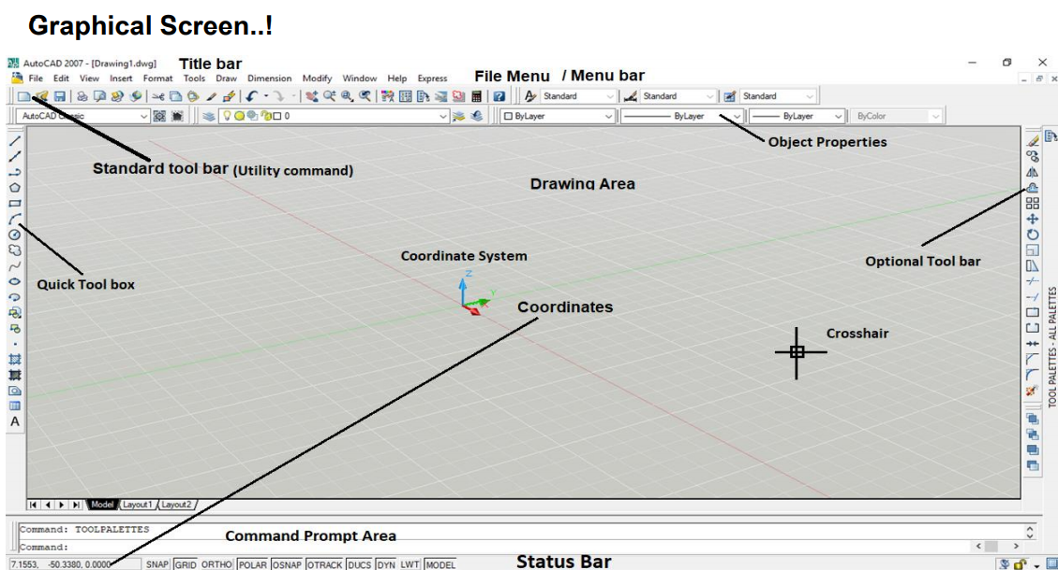

* **Different parts of AutoCAD graphical screen**

**Title Bar:**

The title bar is positioned at the top of the screen and displays the AutoCAD 2007 icon, the AutoCAD Release version and the current drawing name.

**Menu Bar:**

The bar below title bar. It contains different number of options eg file, edit, format etc.

**The Standard toolbar:**

The Standard toolbar is positioned below the screen menu bar and allows the user access to several button icon selections including New, Open, Save, Plot, etc.

**Command prompt area:**

It is located at the bottom and used for typing commands.

**Status Bar:**

Positioned above the Windows taskbar. It gives drawing aid buttons, e.g. SNAP, GRID, ORTHO, POLAR, OSNAP, OTRACK, DUCS, DYN, LWT

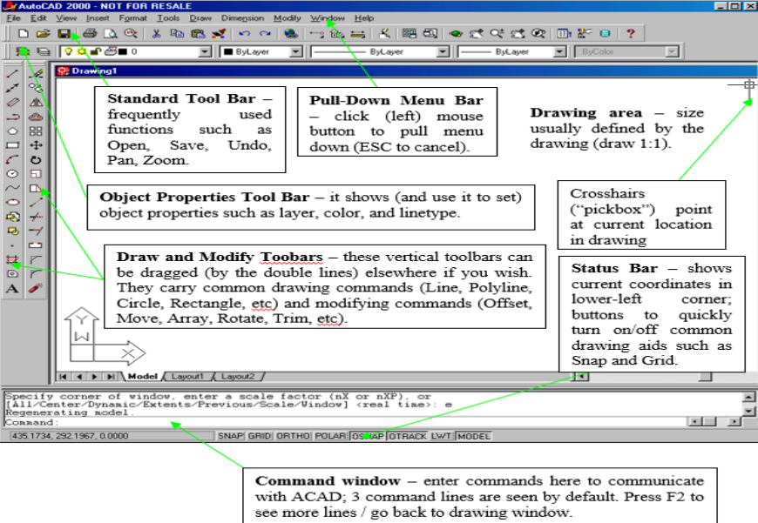

* **Step-wise procedure for launching autocad:**
* By the Start button on the toolbar Windows or through direct clicks on an icon or a file that was made in **AutoCAD**. Here I will not hold back because I believe that you have a base knowledge to work in Windows operating system and know how to run a software application.  After starting the AutoCAD window will appear like this in the picture below where you select the type of work in **AutoCAD 2007**.

[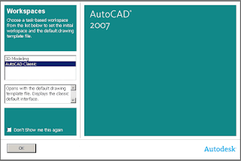](https://3.bp.blogspot.com/-cl8qs3J_XF8/WlpOZ6nemPI/AAAAAAAAAfM/jqdKVQjYmFceRT12kibv4BKSaQL-IRFpgCLcBGAs/s1600/startni-prozor.png)

* After running **AutoCAD** that you may see the following window as shown below (and not, depending on whether this option is turned on) if not, at the end of this page, see how to include and exclude options that you get **STARTUP dialog window**.  
  Setting unit and their accuracy.

[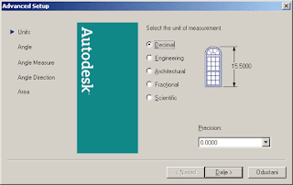](https://4.bp.blogspot.com/-LBvjl-z8ydQ/WlpOw2BXkiI/AAAAAAAAAfQ/2J56-ZkDcV8Jh-DCBhMjFMfhyYfbiMZYACLcBGAs/s1600/advance-startup1.png)

* Set your only angle measurements as well as its accuracy (version number in **decimal form**)

[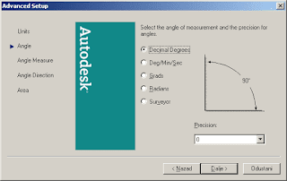](https://2.bp.blogspot.com/-mFmo5n7OPcY/WlpPGTglPYI/AAAAAAAAAfY/qN0bxTeaSv4964XPRogW8aJTblR4hYzZACLcBGAs/s1600/advance-startup2.png)

* Setting the baseline for the direction of drawing **Angle Measure - EAST**

[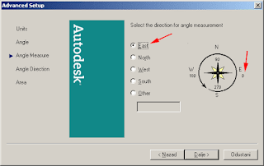](https://2.bp.blogspot.com/-2GkhbFL8yPY/WlpPhDSUuJI/AAAAAAAAAfc/ebl1ifnJXLcZclU_iWHMCX7jBE0RQEdnQCLcBGAs/s1600/advance-startup3.png)

* Setting the direction of drawing a "**Counter Clockwise**" in the opposite **direction** from clockwise (in geodesy is set to **Clockwise**)

[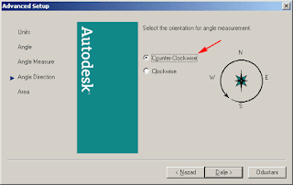](https://3.bp.blogspot.com/-hjE-b6WKHEw/WlpP2oD6xlI/AAAAAAAAAfk/g5GRquoiCXY-5PH0cyrmWznAi2zkDYVRwCLcBGAs/s1600/advance-startup4.png)

* Here in the option area, you can set the size of the drawing area (not a must, but then you can use the scale to print on paper (PLOT)

[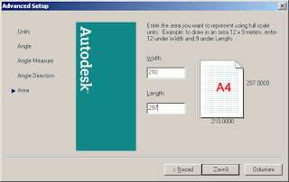](https://1.bp.blogspot.com/-O1N8WNiVWDI/WlpQXQQuW3I/AAAAAAAAAfs/T-Ob-2ZIGW8FPjnEE-Xm-WGIRluq38bpgCLcBGAs/s1600/advance-startup5.png)

* Speaking of determining the size of the area for drawing, as long as you need **STARTUP dialog window**, and furthermore, you can set the size of the area, drawing the border.
* In Command Line, type the **command LIMITS** and then use the size of areas (eg: paper A4 type 210,297 and press Enter.)
* Here you will see that first go Width and then go Length (in 2D there is no height so it is not good to say the width and height). So the paper width is 210 units and the length of paper is 297 units (of course for the measurement unit in the settings we choose millimeters). You can also see that this is PORTRAIT position paper, the landscape position paper to write 297,210 With a text menu, select the Format command **Drawing Limits** and still enter as follows  
    
  "Specify lower left corner or [ON / OFF] <0.0000,0.0000>: 210,297  
    
  If you want to work in the window to see the entire plot area you have selected zoom view by clicking  
  the icon buttons ZOOM  (Or Command: type Z + Enter, then type A + Enter, which means ALL)  
  (You can turn ON, GRID function button - display supporting network, to see where you are located drawing area) For inclusion STARTUP dialog window, follow the next picture below. So in the Command Line, type the command STARTUP and then press ENTER, if you see 0 means that it is starting OFF the window, type 1 and press enter, now you will be when the next launch AutoCAD startup screen appears. (So 0 for OFF and 1 for included)

## AutoCAD Command Field

Command:STARTUP[+enter]  
 Enter new value for STARTUP <0>: 1 [+enter]

[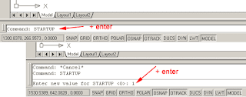](https://1.bp.blogspot.com/-kgXK6EVq2HE/WlpQzfxeDSI/AAAAAAAAAf0/bsnxHIzdATMiBVVSi97YnMmd6_XrHs5aACLcBGAs/s1600/startup1.png)

* **Setting workspace:**
* On the status bar, click Workspace Switching, and select the workspace you want to set current.  (  Find)
* Set a workspace current from the Customize User Interface (CUI) Editor:
* Click Manage tab  Customization panel  User Interface.  Find
* In the Customize tab, Customizations In *<file name>* pane, click the plus sign (+) next to the Workspaces node to expand it.
* Right-click the workspace you want to set current, default or new workspace. Click it.

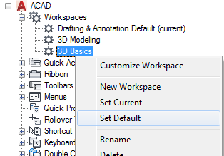

* Click Apply.

## Create and Customize a Workspace:

1. Click Manage tab  Customization panel  User Interface.  Find
2. In the Customize tab, Customizations In <file name> pane, right-click the Workspaces node and click New Workspace.

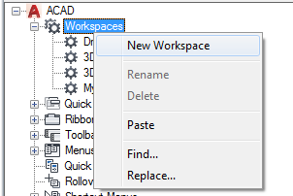

A new, empty workspace (named Workspace1) is placed at the bottom of the Workspaces.

**Tip:** You can also create a copy of an existing workspace by right-clicking a workspace and clicking Duplicate.

1. Right-click Workspace1. Click Rename and enter a new workspace name.
2. In the Workspace Contents pane, click Customize Workspace.

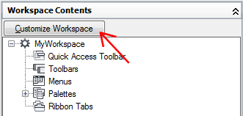

1. In the Customizations In *<file name>* pane, click the plus sign (+) next to the user interface elements to expand them.

**Note:** The Quick Access toolbar, ribbon tabs, toolbars, pull-down menus, and partial CUIx file nodes now display check boxes next to them so you can easily add elements to the workspace.

1. Click the check box next to each user interface element that you want to add to the workspace.

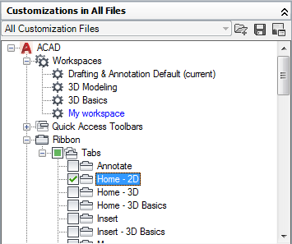

The selected user interface elements are added to the workspace.

1. In the Workspace Contents pane, click Done.

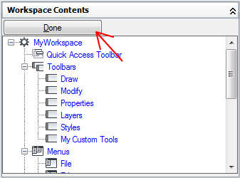

1. Click Apply.

* **Putting the user interface to work:**
* Command Prompt (Typing a Command): A command can be activated by writing its shortcut in command prompt area and pressing enter.

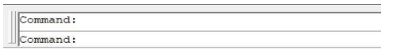

* Canceling a Command: A command can be canceled by pressing Esc button or by left clicking and selecting cancel option. B

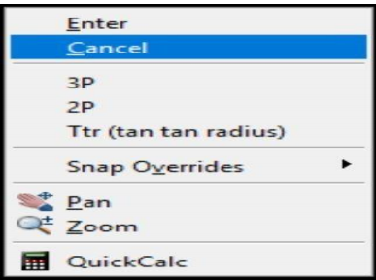

* **Setting tool bar for quick use:**
* 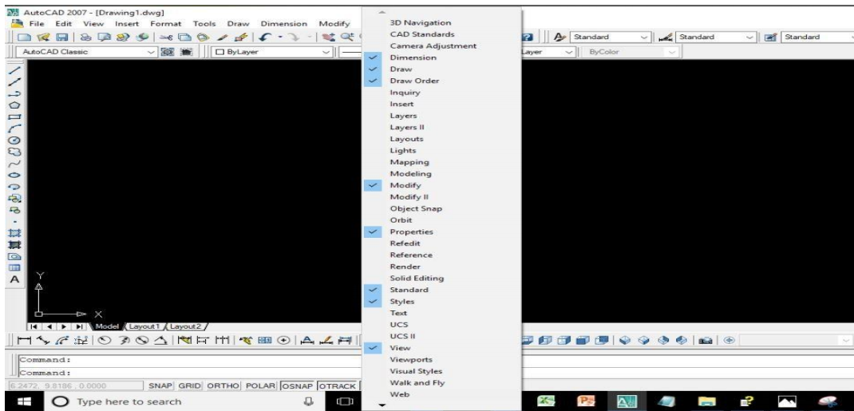Right-click any toolbar button and choose from the list of available toolbars and drag it to desired place.
* Opening, Saving, and Printing drawing:
* Opening Drawing: A drawing can be opened by pressing Ctrl+O or by Clicking on file option in menu bar and then selecting open. It can also be opened by clicking open icon in standard toolbar.
* Saving Drawing: A drawing can be opened by pressing Ctrl+S or by Clicking on file option in menu bar and then selecting save. It can also be saved by clicking save icon in standard toolbar.
* New Drawing: A new drawing can be started by pressing Ctrl+N or by Clicking on file option in menu bar and then selecting New. It can also be started by clicking new icon in standard toolbar.
* Printing Drawing: A drawing can be printed by pressing Ctrl+P or by Clicking on file option in menu bar and then selecting Plot. It can also be printed by clicking plot icon in standard toolbar.
* **Setting up drawing limits:**

Menu bar :- Format > Drawing limits

OR Command:- limits

* Set the drawing areas by limits command. First enter the limits command. It will display the prompt “to specify the lower left corner” and then the next prompt is “specify the upper right corner”. The following is the prompt sequence of the limits command for setting limits.
* Specify lower left corner or [ ON/OFF]: 0,0
* Specify upper right corner :11,9
* **Toolbar:**

Toolbar activate by clicking DTM (right-click) in the territory where the Text menu, just below the zone where the other toolbars, or via a text menu. To set the Toolbar click on View => Toolbars on the text menu. The most widely used toolbars (toolbars) markup are bold.

Toolbar contan the following component:

* **CAD Standard:**

**CAD standards** help optimize the creation and delivery of CAD drawings made by designers, architects and other engineers.

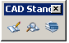

* **Camera Adjustment:**

[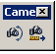](https://3.bp.blogspot.com/-dbTswsuEXcQ/WlpewtZMMFI/AAAAAAAAAhw/KJduCEYsqUUCsBCs6_DjAuvp1NHxU4muQCLcBGAs/s1600/toolbar-camera_adjustment.png) There are several ways to change **camera settings**: Click and drag grips to resize or relocate a lens length or field of view.

* **Dimension:**

We can create horizontal, vertical, aligned, and radial **dimensions** with the DIM command.

[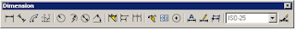](https://3.bp.blogspot.com/-mI8EdBs67HY/WlpfA3aBBHI/AAAAAAAAAh0/ap07L_idW_QI-4cU0avWtvr_bol0Onr4QCLcBGAs/s1600/toolbar-dimension.png)

* **Draw  
  Toolbars DRAW** main strip to **draw** lines, 2D characters, but also we can use this command to **draw** in 3D.

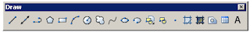

* **Draw Order:**

The **draw order** of objects includes both their display **order** and plotting **order**. Click Home tab Modify panel drop-down list. Find. Click **Draw Order**, and from the drop-down list, choose one of the options.

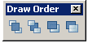

* **Inquiry:**

To calculate the distance and angle between two points.

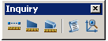

* **Insert:**

 Inserts a block or drawing into the current drawing using the classic version of the **INSERT command**. The classic **Insert** dialog box is displayed.

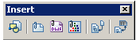

* **Layers:**

Using this **tool** will change the current **layer** by selecting an object as reference. It will use the object's **layer.**

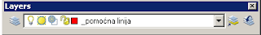

* **Layers II:**

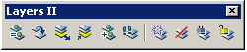

* **Layouts:**

A **layout** is a 2D working environment for creating drawing sheets. The area within a **layout** is called paper space. 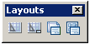

* **Lights:**

The Device **tool** works directly with the Properties palette, allowing you to select from master style **definition** drawings.  
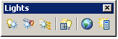

* **Mapping:**

The **AutoCAD** GIS and **Mapping** toolset is model-based GIS **mapping** software that provides access to CAD and GIS data to support planning, design etc.  
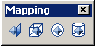

* **Modeling:**

AutoCAD 3D modeling allows you to create drawings using solid, surface, and mesh objects.

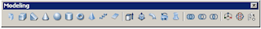

* **Modify:**

 Perform editing operations such as erase, move, and trim on the objects in a drawing. The most common of these **tools** are located on the **Modify** panel of the Home tab.

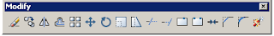

* **Modify II:**

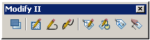

* **Object Snap:**

The **Object Snaps** (Osnaps for short) are drawing aids which are used in conjunction with other commands to help you draw accurately.

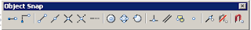

* **Orbit:**

**Object tool** flyouts contain other **objects** that can be created with the same properties.  
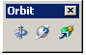

* Properties  
  
* Refedit  
  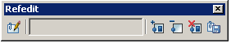
* Reference  
  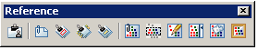
* Render  
  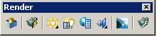
* Solid Editing  
   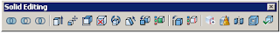
* Standard  
  
* Styles  
  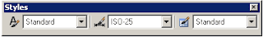
* Text  
  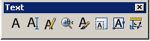
* UCS  
  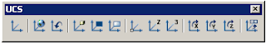
* UCS II  
  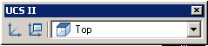
* View  
  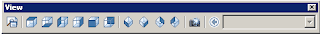
* Viewports  
  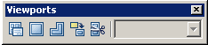
* Visual Styles  
  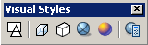
* Walk and Fly  
  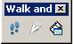
* Web  
  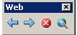
* Workspaces  
  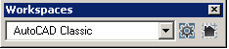
* Zoom

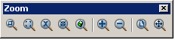

**Lab report no #03**

**Setting Up Drawing unit, Drawing sheet, Dimension style and Text style.**

* **Setting up drawing unit:**

Menu bar: - Format > units

OR Command:- units

* The units command is used to select a format for the unit of distance and angle measurement.
* After entering the units command it will display the Drawing Units dialog box given below which is used to set the units and angles. Then specify the Precision for the units and angles from the corresponding precision drop-down list. After selecting all the set-up press OK.

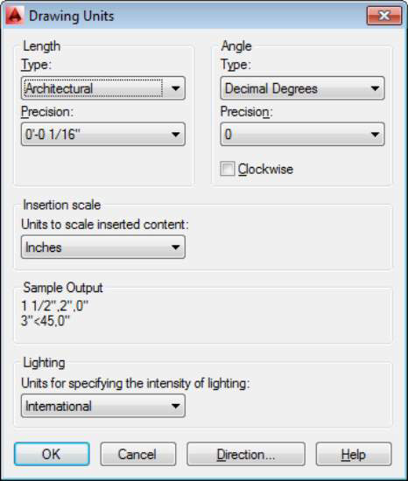

* **Setting up drawing sheet:**
* Launch AutoCAD.
* Click the "View" panel at the top of the window. Note that this is the "View" option between "Parametric" and "Manage," not the "View" option between "Edit" and "Insert."
* Click the "Sheet Set Manager" button in the "Palettes" section of the ribbon at the top of the window. This will open the "Sheet Set" panel at the right side of the window.
* Click the drop-down menu at the top of the "Sheet Set" panel, then click "New Sheet Set."
* Click "An Example Sheet Set," then click "Next."
* Click the example sheet layout that best corresponds to your needs, then click "Next."
* Click inside the "Name of New Sheet Set" field at the top of the window, then type a name for the sheet set.
* Click "Next" to continue, then click "Finish" to generate your sheet layout.

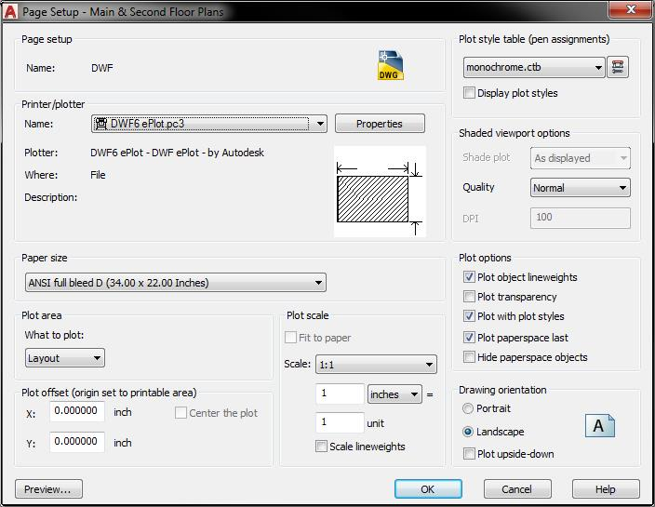

* **Setting up dimension style:**
* Click Home tabAnnotation panelDimension Style. 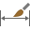 Find
* In the Dimension Style Manager, click New.

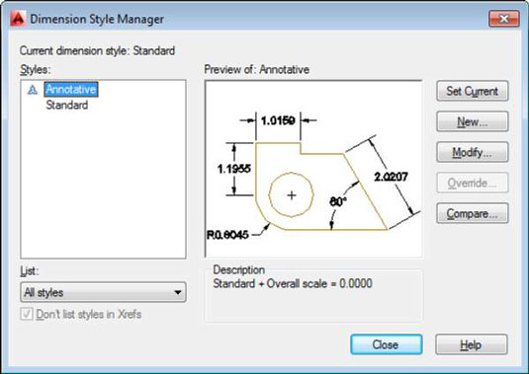

* In the Create New Dimension Style dialog box, enter a name for the new dimension style, and click Continue.
* In the New Dimension Style dialog box, click each tab, and make any changes for the new dimension style.
* Click OK and then Close to exit the Dimension Style Manager.
* **Setting text style:**

1. Click Home tabAnnotation panelText Style.  Find
2. In the given Text Style dialog box, do one of the following:

* To create a style, click New and enter the style name.

Note: Text style names can be up to 255 characters long. They can contain letters, numbers, and the special characters dollar sign ($), underscore (_), and hyphen (-).

* To modify an existing style, select the style name from the list of styles.

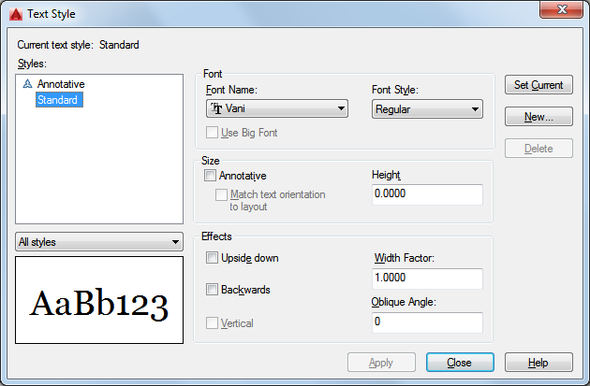

1. **Font.** Under Font Name, select the font you want to use. TrueType fonts display a TrueType icon in front of their names. 

* To assign an Asian-language font, select the name of an SHX font file, check Use Big Font, and select an Asian-language big font.

1. **Size.** In the Height box, enter the text height in drawing units.
2. **Oblique angle.** Under Effects, enter an angle between -85 and 85 in the Oblique Angle box.

A positive value slants text to the right. A negative value slants text to the left.

1. **Character spacing.** Under Effects, enter a value in the Width Factor box.

Entering a value less than 1.0 condenses the text. Entering a value greater than 1.0 expands it.

1. **Annotative.** Check this option so that any text using this style displays uniformly at the same size or scale regardless of the scale of the view.
2. Specify other settings as needed.
3. To update text of the current style in the drawing, click Apply.
4. Click Close.

**Lab report no #04**

**Opening, saving, and Printing AutoCAD sketches Introduction to basic commands (Zoom and Pan)**

* **Procedure of opening AutoCAD sketches :**
* A drawing can be opened by pressing Ctrl+O or by Clicking on file option in menu bar and then selecting open. It can also be opened by clicking open icon in standard toolbar

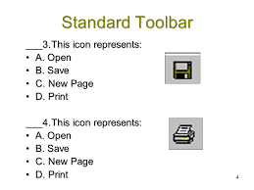

* **Procedure of saving AutoCAD sketches:**
* A drawing can be saved by pressing Ctrl+S or by Clicking on file option in menu bar and then selecting save. It can also be saved by clicking save icon in standard toolbar

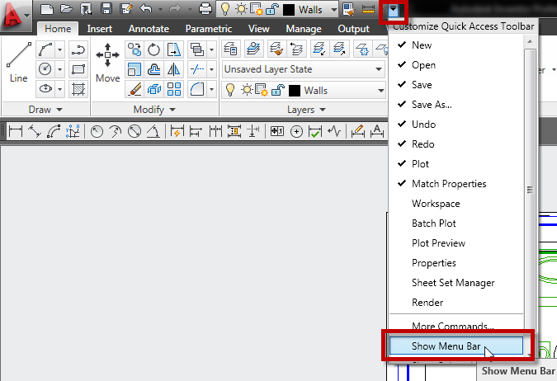

* **Printing AutoCAD sketches:**
* A drawing can be printed by pressing Ctrl+P or by Clicking on file option in menu bar and then selecting Plot. It can also be printed by clicking plot icon in standard toolbar.



* **Draw new AutoCAD sketch:**
* A new sketch can be draw by pressing control+ N or by Clicking on file option in menu bar and then selecting newt. It can also be printed by clicking new icon in standard toolbar.



* **Each option in zoom command:**
* ZOOM does not change the absolute size of objects in the drawing. It changes only the magnification of the view.
* Zoom Shortcut Key: z → enter
* Zoom command contain the following options:

Zoom options: Real Time, Extents, Previous, Dynamic, All, Dynamic, Window.

1. **Zoom all:**

* Zooms to display all visible objects and visual aids. Adjusts the magnification of the drawing area to accommodate the extents of all visible objects in the drawing.
* 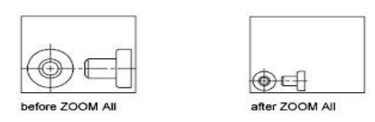 Shortcut Key:- z → enter → a → enter

1. **Zoom dynamic:**

* Zoom using a rectangular view box. The view box represents drawing view, which can be shirked or enlarged and move around the drawing.
* Shortcut Key:- z→enter→d→enter

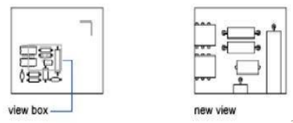

1. **Zoom extents:**

* Zooms to display the maximum extents of all objects.
* Shortcut Key:- z→enter→e→enter

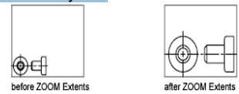

1. **Zoom previous:**

* Zooms to display the previous view.
* Shortcut Key:- z→enter→p→enter

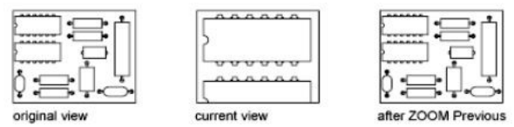

1. **Zoom window:**

* Zooms to display an area specified by a rectangular window.
* Shortcut Key:- z→enter→w→enter

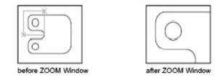

1. **Zoom object:**

* Zooms to display one or more selected objects as large as possible.
* Shortcut Key:- z→enter→o→enter

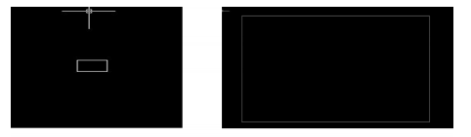

1. **Zoom real time:**

* Zooms interactively to change the magnification of the view.
* The cursor changes to a magnifying glass with plus (+) and minus (-) signs.
* Shortcut Key:- z→enter→r→enter
* **Pan command:**
* 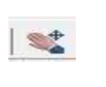Shifts the view without changing the viewing direction or magnification.
* Shortcut Key:- p→enter
* It can also be activated by clicking on hand icon at the top

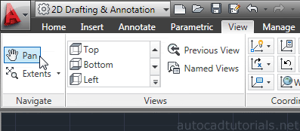

**Lab report no #5**

**Introduction to Status bar and function of different toggle button in status bar**

* **Introduction to status bar:**
* The **Status** bar appears in the lower-right corner of the program window
* The status bar displays the cursor location, drawing tools, and tools that affect your drawing environment.
* The status bar provides quick access to some of the most commonly used drawing tools.
* We can toggle settings such as **grid, snap, polar tracking, and object snap**.
* Note that the available tools may change, depending on whether you are working in model space or paper space.
* If there are more tools than can fit onto a single row, the Status bar may wrap onto two rows.
* we can also access additional settings for some of these tools by clicking their drop down arrows
* we can also toggle some of these settings with the function keys on your keyboard (F1 - F12).

**Note:** Not all tools are displayed by default; you can choose what tools to display from the Customization menu, the right-most button on the status bar. The tools displayed on the status bar might change depending on the current workspace and whether the Model tab or a layout tab is currently displayed.

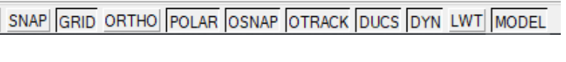

* **Function of different toggle buttons in status bar:**

Status bar or Status Toggle includes Snap, Grid, Ortho, Polar, Osnap, Otrack, Dyn.

1. **SNAP:**

* Shortcut for snap is F9.
* Increment Snap controls the movement of the cursor.
* If it is off the cursor will move smoothly .
* If it is ON, the cursor will jump in an incremental movement .
* The increment spacing can be changed, at any time using TOOLS/DRAFTING SETTINGS
* The default spacing is 0 .250 It restricts cursor movement to specified intervals.

Command: snap specify a distance, enter an option or press enter.

Spacing - Activates snap mode with the value you specify.

Rotate - Sets the rotation of the snap grid. Style - format of the snap grid, standard or isometric. It basically helps to draw the object in its required position

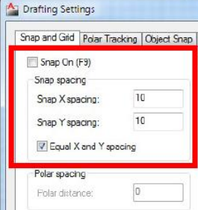

1. **GRID:**

* Shortcut for grid is F7.
* The grid is merely a visual “drawing aid” .
* The default spacing is 1 unit .
* You may change the grid spacing at any time using : TOOLS/DRAFTING SETTINGS .
* It displays a dot grid in the current view port .

Command : grid Grid spacing (x) or ON/OFF/Snap/Aspect/ : specify a value or enter an option .

Snap - Sets the grid spacing to the current snap interval as set by the snap command . Aspect - Sets the grid to a different spacing in x & y

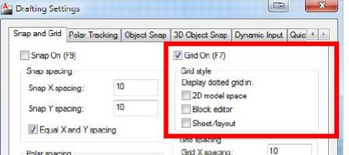

1. **ORTHO:**

* SHORTCUT FOR ortho is F8.
* When ORTHO is ON, the cursor movement is restricted to horizontal or vertical .
* When ORTHO is OFF, the cursor is free to move .

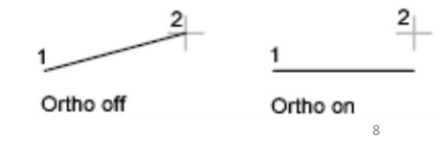

1. **OSNAP(command):**

* Shortcut:- F3.
* specific object snaps can be set to stay active until you turn them off.
* The Object Snaps (Osnaps for short) are drawing aids which are used in conjunction with other commands to help you draw accurately .
* Osnaps allow you to snap onto a specific object location when you are picking a point . **For example,** using Osnaps you can accurately pick the end point of a line or the center of a circle . It can be activated by clicking OSNAP option in status bar.
* Shortcut Key : - OSNAP → enter , A dialogue box appears in which click the option select all and press ok .

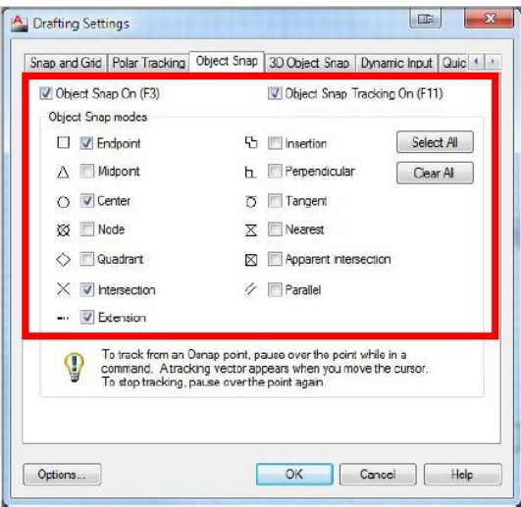

1. **Polar:**

* Shortcut:- F10.
* POLAR TRACKING creates “alignment paths” at specified angles .
* POLAR Command: - Polar tracking restricts cursor movement to specified angles . It can be activated by clicking the POLAR option in status bar.
* Allows cursor movement to the horizontal or vertical.

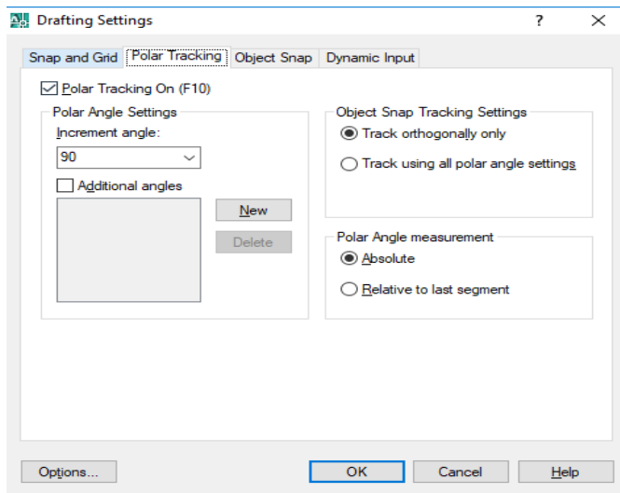

1. **OTRACK:**

* OTRACK Command: - Object Snap Tracking (OTRACK)
* Shortcuts:- F11.
* OBJECT SNAP TRACKING creates “alignment paths” at precise positions using object snap locations.
* Works with OSNAP and POLAR to help align new points with existing locations in your drawing.
* OTRACK makes it easy to draw a new rectangle in line with an existing one or draw a circle to align vertically with the midpoint of a line and horizontally with an intersection.
* It can be activated by clicking OTRACK option in status bar

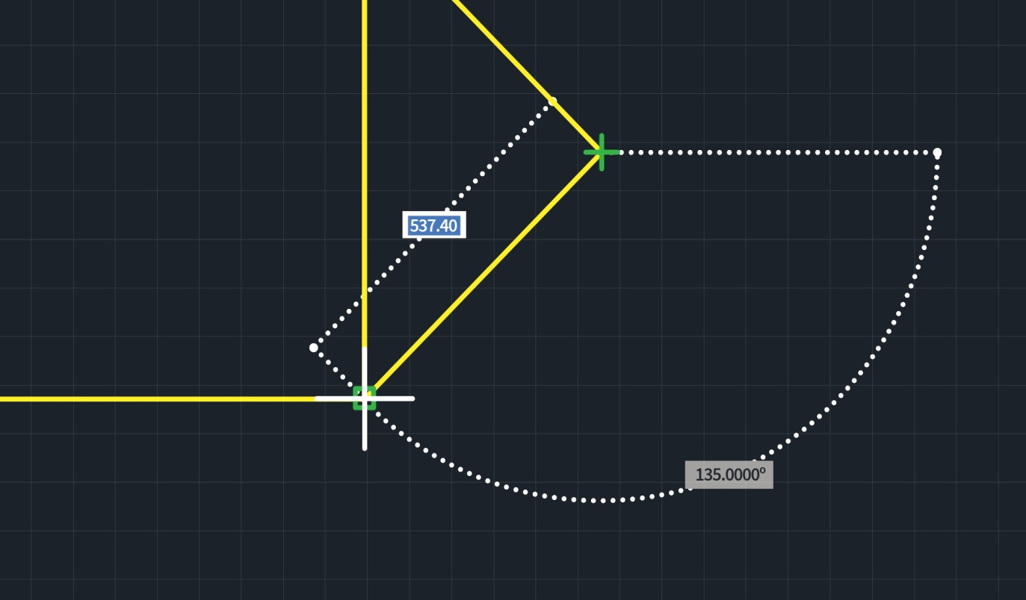

1. **DUCS:**

* Stand for Dynamic User Coordinate System
* Temporarily aligns the XY plane of the UCS to a planar face on a 3D solid, planar mesh element, or planar point cloud segment while creating an object.
* Dynamic UCS is turned on (default).
* Shortcut key:- F6

1. DYN:

* Dynamic input provides a command interface near the cursor in the drawing area.
* Dynamic tooltips provide an alternative way to enter commands.
* When dynamic input is turned on, a tooltip displays dynamically updated information near the cursor.
* When a command is in progress, you can specify options and values in the tooltip text box.
* **Shortcut key: - F12.**

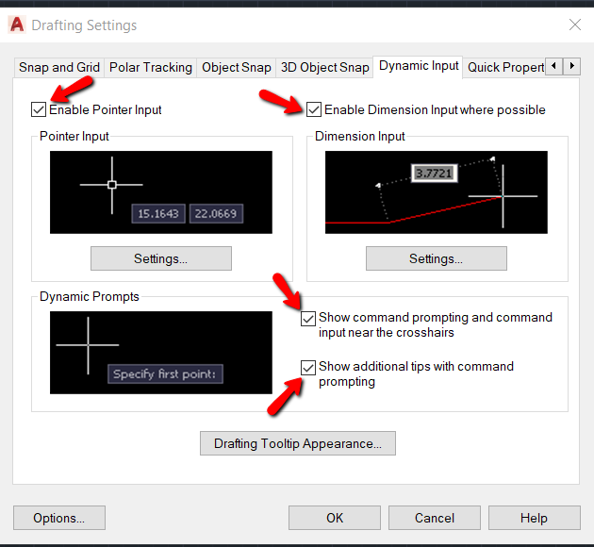

**Lab report no #06**

**Introduction to 2D workspace to 3D, Command Prompt window & Repetition of commands, UCS icon in 2D, Blue grip &its size (stretch, lengthen), cross hair (pick box & Size), Selection Window (From Right to Left & Left to Right)**

* **Introduction to 2D &3D workspace:**

In AutoCAD, you can use workspaces to optimize your drawing area based on the type of task you are working on. AutoCAD workspaces allow you to automatically set and display specific menus, toolbars, palettes, and ribbon panels depending on the context of the task you’re working on. You can choose between the workspaces that come with AutoCAD, like 2D Drafting and Annotation, 3D Basics, and 3D modeling, or you can create your own custom workspace by modifying the work area to your liking. For example, using the 3D Modeling workspace in AutoCAD provides more screen space by removing unnecessary menus while still providing quick access to the Solid, Surface, and Mesh ribbon panels.

* **Procedure to convert 2D to 3D workspace:**
* Open the Workspaces drop-down list on the Quick Access toolbar, or click the Workspace Switching button on the status bar and then choose 3D Modeling.

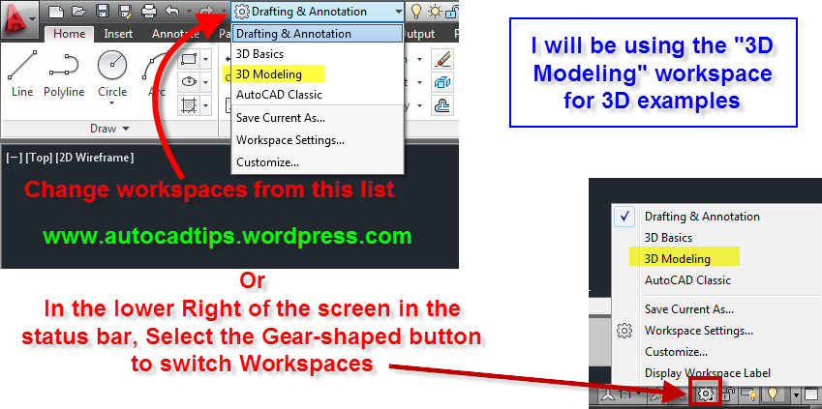

* Click the Application button and choose New; then click Drawing
* The Select Template dialog box appears.

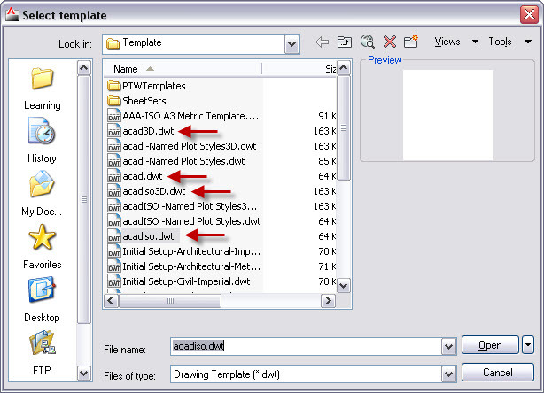

* Choose acad3d.dwt if you’re working in imperial units or acadiso3d.dwt if you’re working in metric. Click Open.
* A 3D modeling space appears where, rather than look straight down at the drawing area, you look at it at an angle from above.

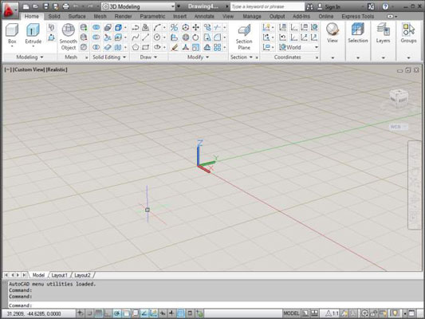

* **Introduction to command prompt window:**

The three- to five-line rectangular window at the bottom of your computer screen is the area where we can enter specific commands by typing on the keyboard. When we invoke commands from pull-down or clickable menus, the corresponding command text often appears in the Command Window.. It has become a little smaller in today’s version of AutoCAD.

The command prompt can help quickly activate a command, and mostly help to access sub-features of commands as you will notice in a minute.

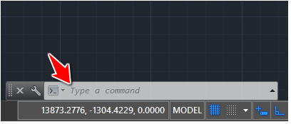

* **How to enter a command:**
* Choose from the pull-down menu, or
* Click appropriate button on a toolbar, or
* Enter command on the command line

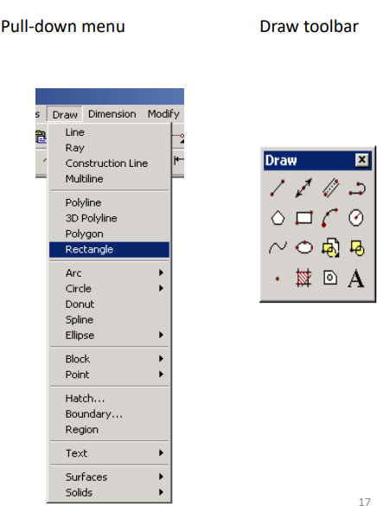

**Let us take an example suppose circle, to know that how we use command window.**

* Type **CIRCLE** and hit Enter

The following appears

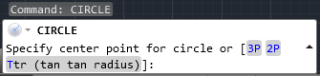

* Specify the center of the circle by a click on the drawing area.

[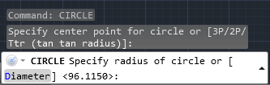](https://cdn-0.tutorial45.com/wp-content/uploads/2015/03/AutoCAD-tutorial2.png)

* Type D and Hit Enter

[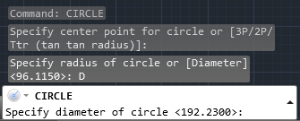](https://cdn-0.tutorial45.com/wp-content/uploads/2015/03/AutoCAD-tutorial3.png)

* You now see AutoCAD is no longer requesting the **Radius**, but the **Diameter**. So we bypassed the radius step and told AutoCAD we would instead like to specify the diameter, and all was done using the command line.
* At this point, you can type 5 and hit Enter, and 5 units will be the Diameter of your circle.
* **Repetition of command:**
* You probably know that after you execute an AutoCAD command, you can press Enter to repeat it. But it might be quicker to set a command to repeat automatically, if you know in advance that you’ll use it a number of times in a row.
* Some commands repeat automatically. In a sense, the LINE command does this, prompting you automatically for a new segment. and the COPY command prompts you to create additional copies
* **Procedure for repetition of command automatically:**

1. Click Tools menu > Customize > Interface.
2. Click the Customize tab in the Customize User Interface editor.
3. In the Command List panel, click New. A new command (named Command1) will be displayed in both the Command List panel and the Properties panel

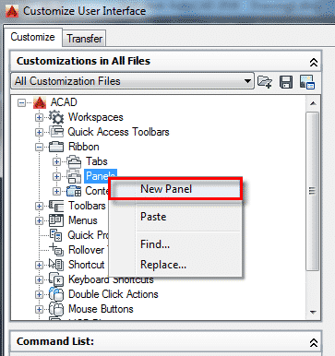

1. In the Properties panel, do the following:

* In the Name box, enter a name for the command. The name will be displayed as the tooltip or menu name when you select the command.
* In the Description box, enter a description for the command. The description will be displayed on the status bar when the cursor hovers over the menu item or toolbar button.
* In the Macro box, enter a macro for the command. For example, for the CIRCLE command, you would enter  **\*^C^C_Circle**.

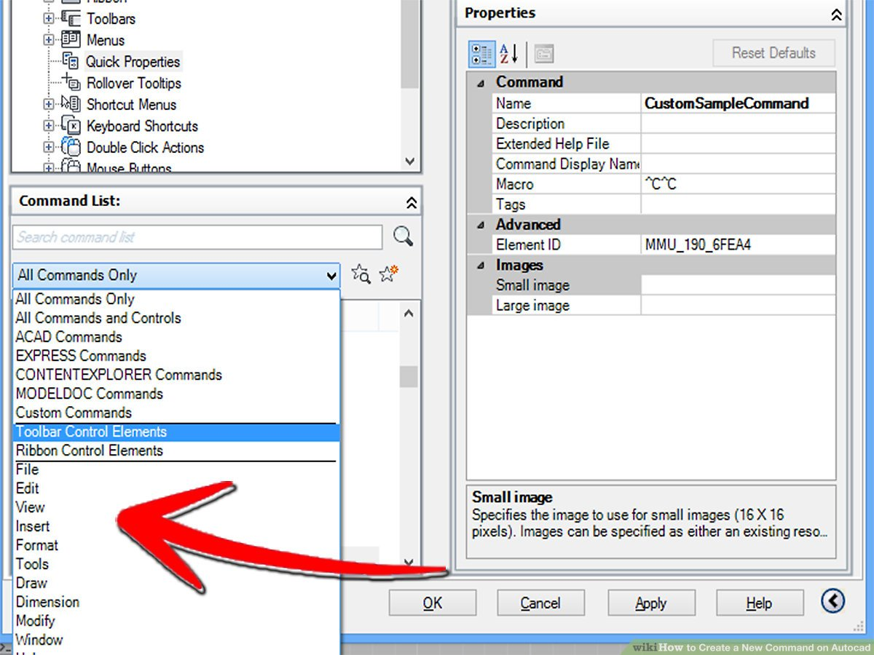

**Note:**Adding an asterisk (*) before the command definition (*^C^C_Circle) will cause the command to repeat until you select another command or press the ESC key.

* **UCS icon in 2D:**
* Controls the visibility, placement, appearance, and select ability of the UCS icon.
* The UCS icon indicates the location and orientation of the current UCS. You can manipulate the UCS icon using grips. This is controlled by the UCSSELECTMODE system variable.

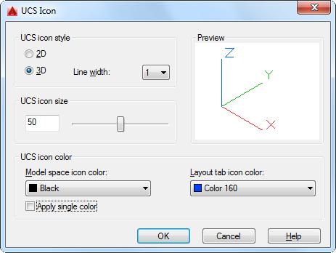

Note: If the location of the UCS origin is not visible in a viewport, the UCS icon is displayed in the lower-left corner of the viewport instead.

* Different user coordinate system icons are displayed in paper space and model space. In model space, you can choose between 2D and 3D icon display styles (see the Properties option):
* **2D**. The letter *W* appears in the *Y* portion of the icon if the UCS is coincident with the WCS (World Coordinate System). If the UCS is rotated so that the Z axis lies in a plane parallel to the viewing plane—that is, if the XY plane is edge-on to the viewer—the 2D UCS icon is replaced by a broken pencil icon.
* **3D**. A square is displayed in the *XY* plane at the origin if the current UCS is coincident with the WCS, and you are viewing the UCS from above (the positive *Z* direction). The square is missing if you are viewing the UCS from below. The *Z* axis is solid when viewed from above the XY plane and dashed when viewed from below the *XY* plane.

The following example display 2D & 3D UCS icons viewed in model space and a UCS icon viewed in a paper space layout..

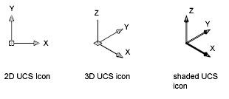

* **Blue grip and its size:**

Entity grips allow AutoCAD drawings to be edited in an entirely new way. Without entering any edit commands, you can stretch, move, copy, rotate, scale, and mirror entities. You can also snap to geometric features such as endpoints, midpoints, centers, quadrants without entering object snaps. Grips are the small squares that appear when objects are selected with the crosshairs directly from the command prompt.

Grip setting:

* Choose Tools, Options...

or

* Type DDGRIP Sat the command

prompt.

Command: DDGRIPS

* Choose the Selection tab from the dialog box.

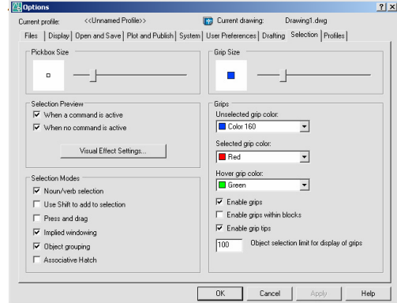

**How to use grip:**

* Pick the objects you want to edit.
* Pick one of the grips to use as the base grip.
* Press the SPACE BAR or RIGHTMOUSE BUTTON to cycle through the grip modes. or
* Type The keyword for the mode you want: Stretch (ST) Stretch the objects. Move (MO) Move the objects. Rotate (RO) Rotate the objects. Scale (SC) Scale the objects. Mirror (MI) Mirror the objects.
* Drag the mouse to perform the operation.
* Types C to create a new copy of the selection set enter C.
* Type X to exit Grip mode.

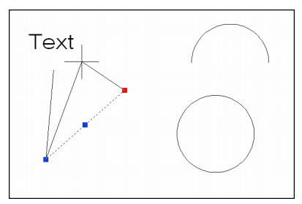

**Grip Size:**

* Changes the size of grips.To adjusts the size of grips, move the slider box left or right.
* AutoCAD stores the pixel size (1-255) of the grips in the GRIPSIZE system variable.
* Changes the size of grips. To adjust the size of grips, move the slider box left or right.
* AutoCAD stores the pixel size (1-255) of the grips in the GRIPSIZE system variable.

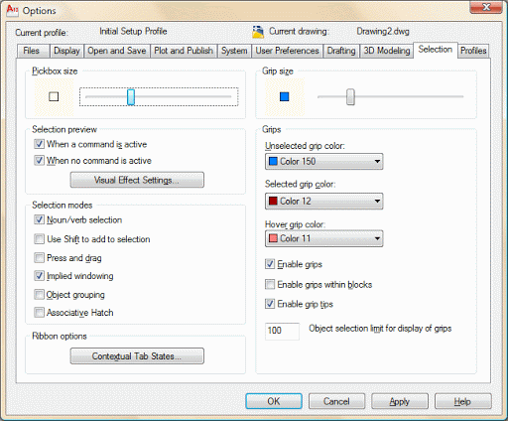

* **Cross hair:**

The AutoCAD crosshairs are the primary cursor used to draw with the software. If your business works with AutoCAD files created by other users, you may encounter crosshairs that are rotated from the normal position. The rotated crosshairs can have an impact on your drawings, forcing you to make adjustments in order to use the software as normal. By using the SNAPDRAG command, you can rotate the crosshairs back to the standard position.

* Start AutoCAD and click the "Command" line at the bottom of the window.
* Type "SNAPDRAG" and press "Enter." The "Command" line changes to "Enter new value for SNAPANG:," where "x" is the current number setting for the crosshairs.
* Enter "0" and press "Enter" to rotate the crosshairs to the normal position. You can also experiment with different crosshairs rotations by entering different values for SNAPANG.

**How to change crosshair size:**

1. Right-click in an empty place in the drawing area and choose Options or click Application button  > Options.
2. On the Selection tab, change the Pick box Size by moving the slider.
3. On the Display tab, change the Crosshair Size by entering a number or moving the slider.

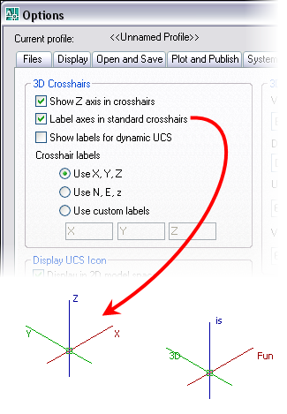

**Lab report no #07**

**Introduction to AutoCAD Coordinate system**

**(Absolute, Relative & Polar Coordinate System)**

* **Introduction to AutoCAD coordinate system:**
* AutoCAD uses a standard XY Cartesian coordinate notation with a horizontal x-axis and a vertical y-axis, as shown in Figure 2.1.

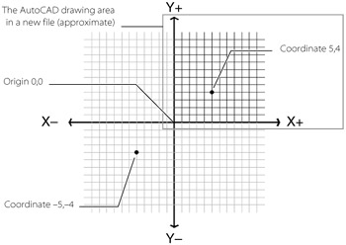  
 Figure 2.1: AutoCAD's coordinate system

* In a new drawing, AutoCAD shows the positive X and Y range of coordinates with the 0,0 coordinate, or *origin*, placed in the lower-left corner of the drawing area.
* The origin is an important coordinate location because you can use it as a reference for multiple drawings. For example, you can use the origin in a set of house plans to coordinate locations among a site plan drawing, a landscape drawing, and a floor plan.
* Many AutoCAD commands ask you to choose a location by entering a point.

**For example**, if you start the Line command, you'll see the following prompt:

**Specify first point:**

You can specify exact coordinates by entering the X and Y coordinates separated by a comma. You give the X coordinate first and then the Y coordinates. For example, you enter a location that is 5 units in the X direction and 4 units in the Y direction as **5, 4** (see Figure 2.1). If you want to include the Z coordinate for a 3D location, you include it at the end of the list with a comma, as in 5,4,2; in this case, 2 is the Z coordinate. When you enter coordinates in this way, you are said to be using *absolute* coordinates, since these are exact locations in the overall coordinate system.

* **Absolute coordinate system:**
* Absolute coordinate entry is the default.
* Absolute coordinate entry always counts from the origin.
* When drawing lines, AutoCAD is ready to place the next vertex wherever you tell it to go:

1. Type L on the command line and press enter
2. Type 4,6 on the command line and press enter
3. Type 5,3 on the command line and press enter
4. Press enter to finish the Line command

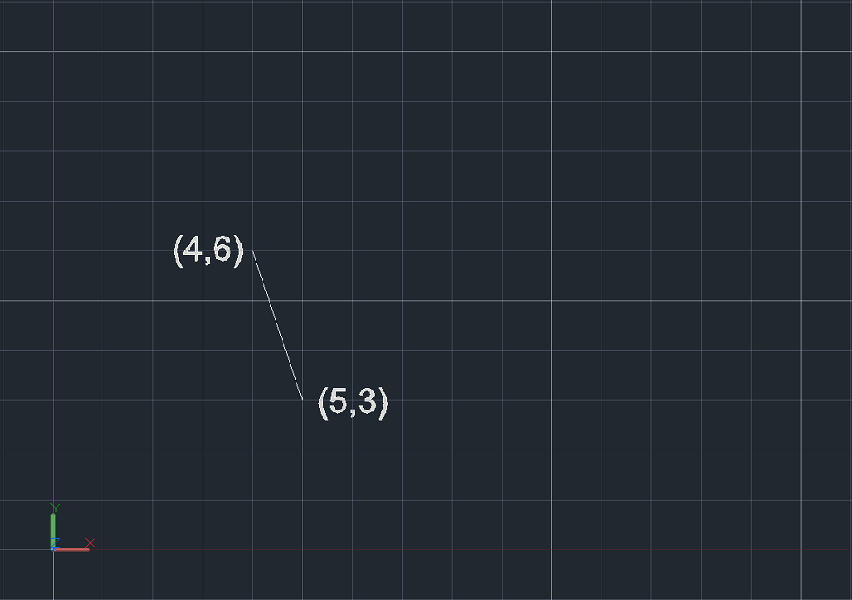

We just told AutoCAD we wanted a line starting at 4,6, and ending at 5,3.  It made a segment between those two points.  The first point is 4 to the right and 6 up from the origin.  The second point is 5 to the right and 3 up from the origin.  The line is the shortest distance between those two points.

* **Relative coordinate system:**
* For relative coordinates, AutoCAD does not count from 0,0.  Instead, the reference point is the previous point in the drawing.
* Let’s draw another line, and see what it looks like compared to the old one:

1. Type L on the command line and press enter
2. Type 4,6 on the command line and press enter
3. Type @5,3 on the command line and press enter
4. Press enter to finish the line command

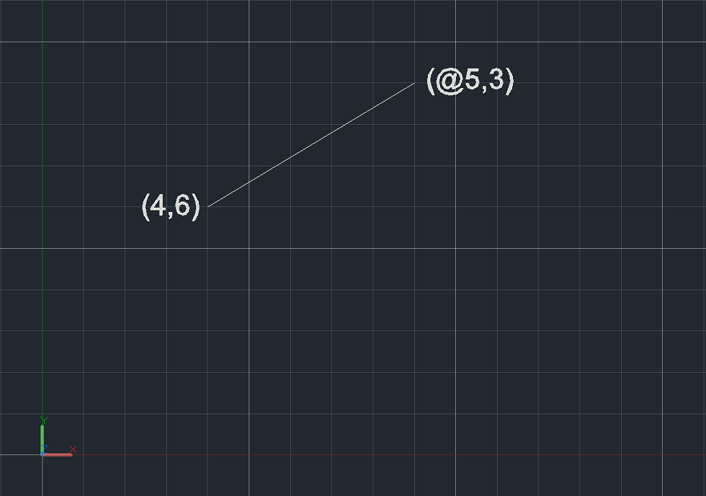

AutoCAD recognizes the @ symbol as instructions to count using relative coordinates.

Notice the difference.  While both lines made thus far started at the same point, this time, for the second vertex, AutoCAD counted 5 over and 3 up from the first vertex, and made the line between those two locales.

* **Polar coordinate system:**
* Polar coordinates are named for their “pole”; the reference point to start counting from, which is similar in concept to the origin.
* Polar coordinates employ one radial distance and one angle (by convention, the angle is measured counterclockwise from the x-axis).
* The angle signifies the direction, and the distance is how far to go in that direction from the pole.

Polar coordinates in AutoCAD are given as R<Degrees, where:

* “R” is the radial distance
* “<” is the less than sign (but in this case represents the angle)
* “Degrees” is the value of the angle in degrees

 Relative coordinates also work with polar input.

Let’s delete the lines we drew and work via the command line again:

1. Type L on the command line and press enter
2. Type 4,6 on the command line and press enter
3. Type @5<60 on the command line and press enter
4. Press enter to finish the line command

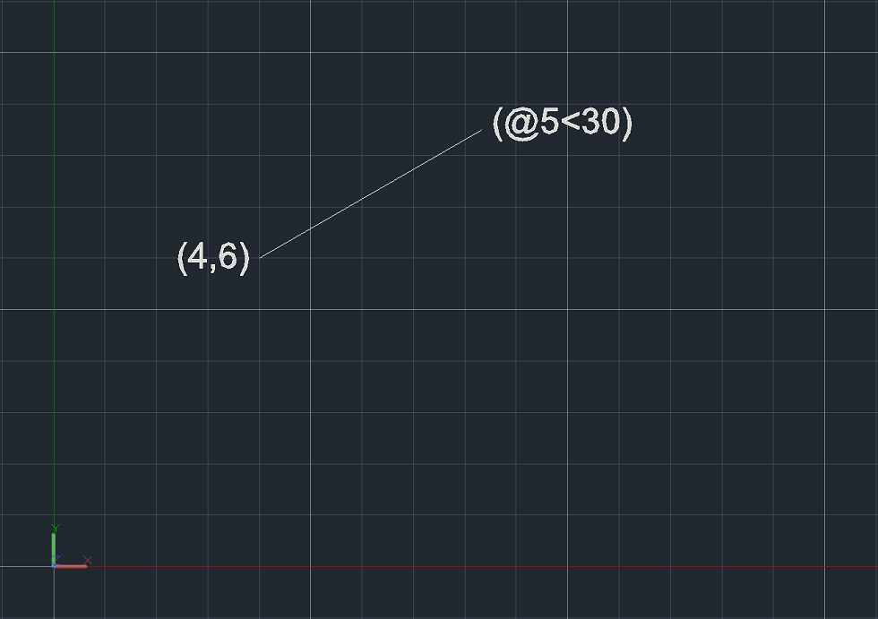

The above line started at 4,6 (which is input in absolute Cartesian coordinates).  Since the next line had the @ symbol, that means the previous point (4,6), became the pole, or reference point for the relative coordinates.

We input the polar coordinates as @5<60, which means the length of the line is 5 and the angle counterclockwise from the x-axis is 60 degrees.

**Lab report no #08**

**Introduction to Draw Toolbar and different commands**

* **Introduction to toolbar:**
* Toolbars **DRAW** main strip to draw lines, 2D characters, but also we can use this command to draw in 3D.
* The same commands can be used via the draw.
* Locate the tape can be anywhere on the working window in the system of **Drag and Drop**.
* **Line, Ray, Construction line, Multiline, Polyline, 3D Polyline, Polygon, Rectangle, Helix, Arc, Circle, Donut, Spline, Ellipse, Block, Table, Point, Point, Hatch, Boundary, Region, Text.**

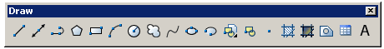

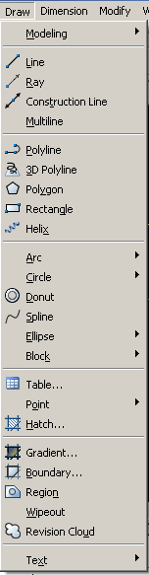

* Lines using the line command can be drawn with the mouse, as well as absolute, relative, polar coordinates and the other concerned the chapter coordinator.
* Similarly, we can draw lines directly over the command line prompt by entering the line command and then by giving certain coordinates.
* **Different command In draw toolbar:**

Draw toolbar consist of different commands given below:

* + 1. **Line command:**
* The line is a command which is used in almost every drawing actually without line you are not able to draw any object in a drawing project.
* Line is an interesting tool in AutoCAD and getting familiar with it is a good feeling and after having good knowledge about the lines in AutoCAD you will find you have developed an excellent command on AutoCAD designing software.
* Lines can be drawn by any one of the following three methods using LINE command.

1. 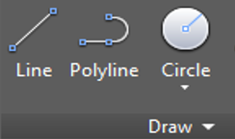Using Absolute Co-ordinates
2. Using Relative Co-ordinates
3. Using Polar Co-ordinates

* + 1. **Ray command:**
* Creates a linear object that starts at a point and continues to infinity.
* The **ray** is extended to the edge of the display in the direction defined by the starting point and the through point.
* The prompt for a through point is redisplayed so you can create multiple **rays**.
* Press enter to end the command.

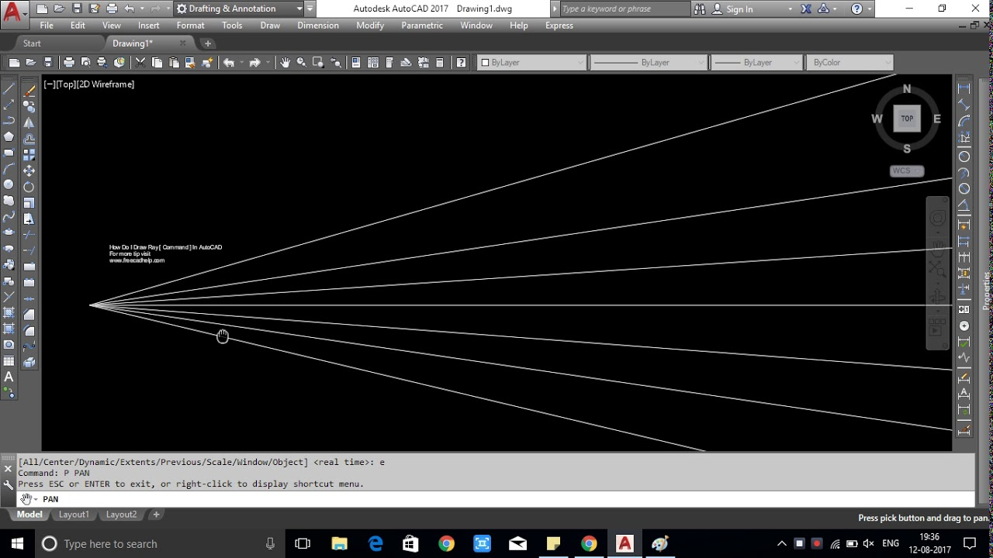

* + 1. **Polyline:**
* A Polyline is a connected sequence of line and arc segments.
* **Draw a thick line of width 2 units from (8, 4) to (6, 7) using pline command.**

Command: pline

From point: 8, 4 Arc/close/Half width/length/undo/width/ :

Width

Width: 2

Next point: 6, 7

Next point:

A box drawn by using pline will act as one object instead of four discrete lines

* + 1. **Construction line:**
* Also known as xlines.
* Construction lines are temporary line work entities that can be used as references when creating and positioning other objects or line work.



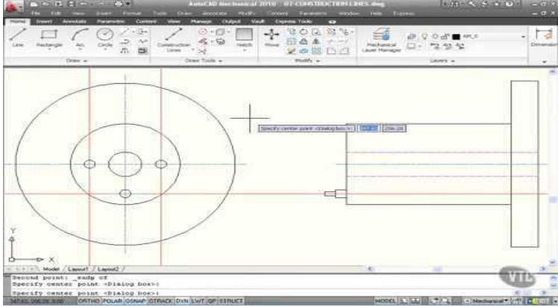

* + 1. **Arc:**
* 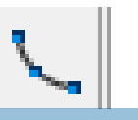Arc Command can be activated by clicking its icon in drawing toolbar or by clicking on draw option in menu bar and then selecting arc.

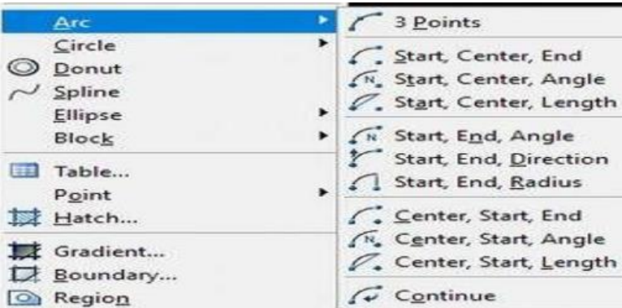

* + 1. **Circle**:
* Circle command can be activated by clicking its icon in draw toolbar or by clicking on draw option in menu bar and then selecting circle

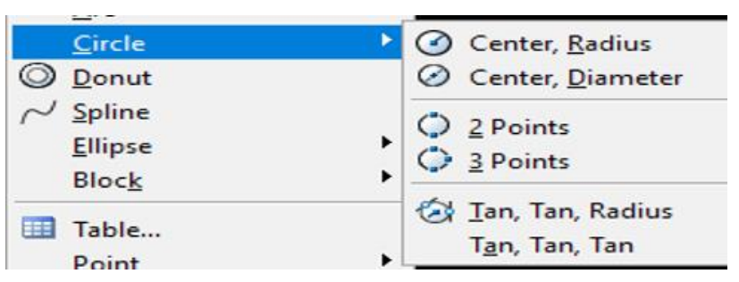

* + 1. **Polygon:**
* Circle command can be activated by clicking its icon in draw toolbar or by clicking on draw option in menu bar. Polygon may be circumscribed or inscribed.

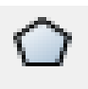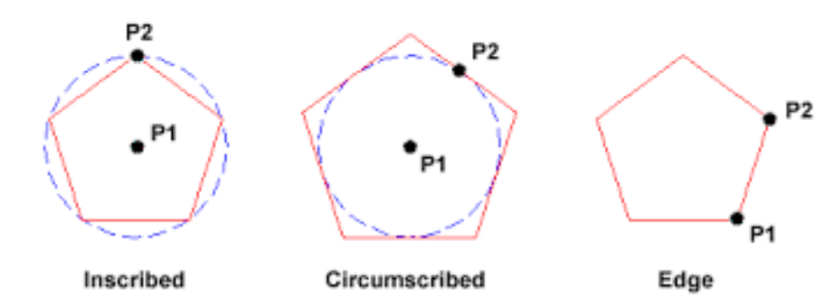

* + 1. **Rectangle: (rec):**
* 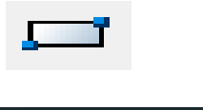It can be activated by clicking its icon in draw toolbar. It has different options after selecting first point like other corner or Area / Dimensions /Rotation.

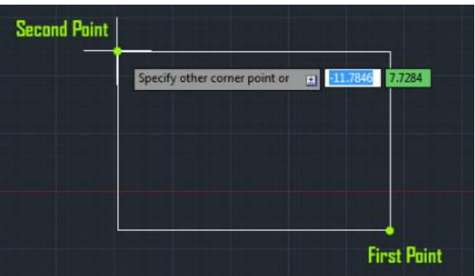

* + 1. **Revision Cloud: (Revcloud):**
* 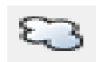It can be activated by clicking its icon in draw toolbar. Revision cloud is used for highlighting parts of a drawing.

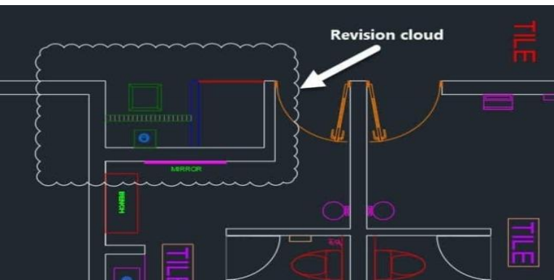

* + 1. **Ellipse:**
* 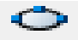It is used to draw ellipse. It can be activated by clicking its icon in draw bar

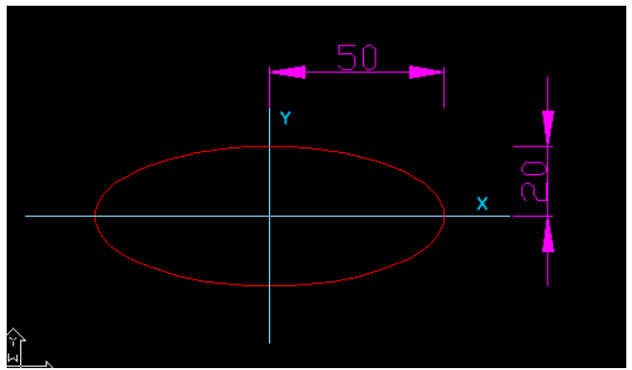

* + 1. **Spline :**
* Creates a smooth curve that passes through or near a set of fit points, or that is defined by the vertices in a control frame. Find.
* **SPLINE** creates curves called no uniform rational B-**splines** (NURBS), referred to as **splines** for simplicity.
* **Splines** are defined either with fit points, or with control vertices

.

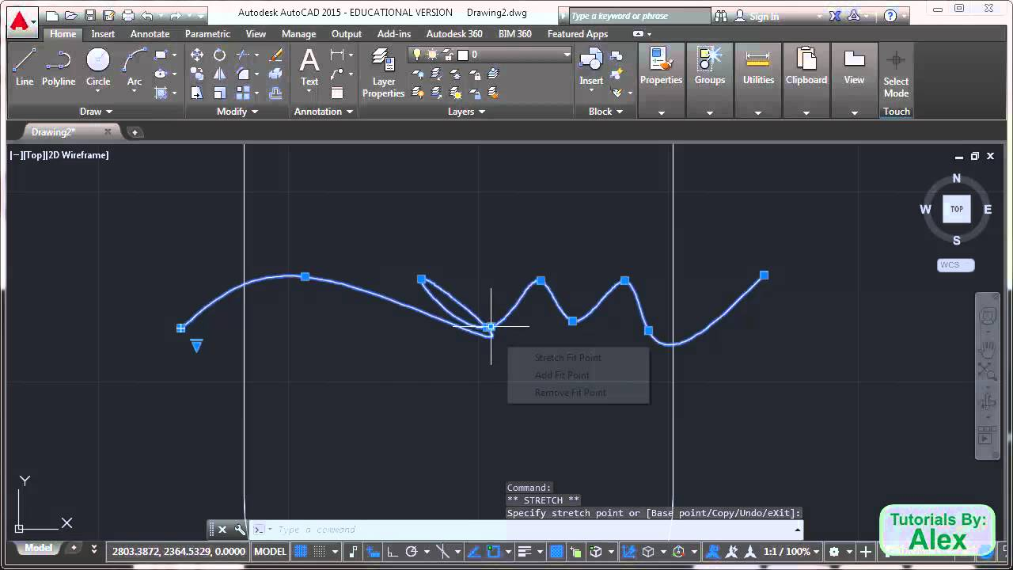

* + 1. **Block:**
* In AutoCAD, a block is a collection of objects that are combined into a single named object.

**Creating Block:** 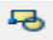

Block can be created by clicking its icon in draw toolbar. After clicking its icon a dialogue box appears that asks to select object and after selecting object a pick point is chosen and it is saved with a name. Any change done in block will change all objects.

**Inserting Block:** 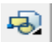

Block can be inserted by clicking its icon in draw toolbar. After clicking its icon a dialogue box appears that asks to browse the block to be inserted.

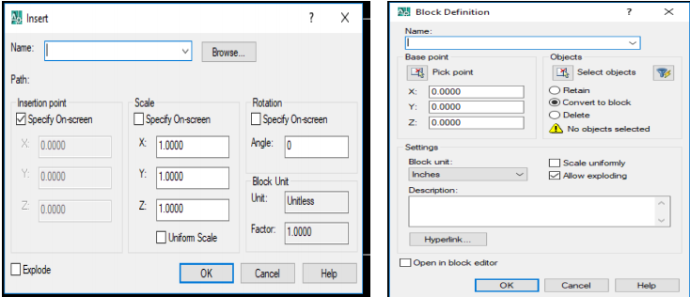

* + 1. ** Text:**
* Text command is used to write the text in drawing.
* Text can be added by clicking its icon in draw toolbar.
* After clicking the icon a block is made by specifying two points, after this text can be written and clicked ok.

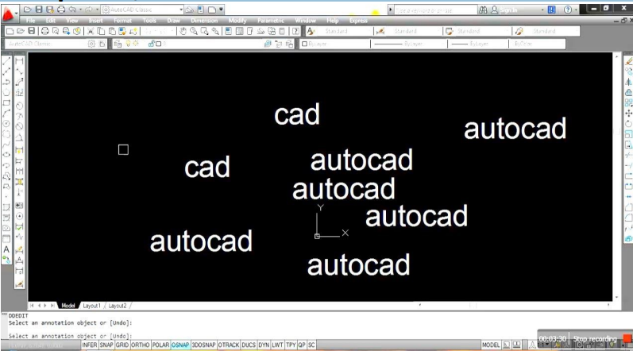

**Lab report no #09**

**Introduction to Modify Toolbar and different commands**

* **Introduction to modify toolbar:**
* **The Modify tools are among those most frequently used.**
* The tools are found in the Home/Modify panel.
* A click on the arrow at the bottom of the Home/Modify panel brings down a further set of tool icons. They can also be selected from the Modify drop-down menu.
* In the AutoCAD Classic workspace, they can be selected from the Modify toolbar.
* the toolbar to work with: **Copy, Mirror, Array, Offset, Move, Rotate, Trim, Extend, chamfer, Fillet, Explode, Pedit** etc.
* The same commands can be used via **MODIFY File Menu**. Locate the tape can be anywhere on the working window in the system of 'Drag and Drop'.

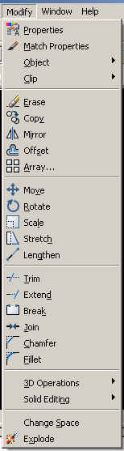

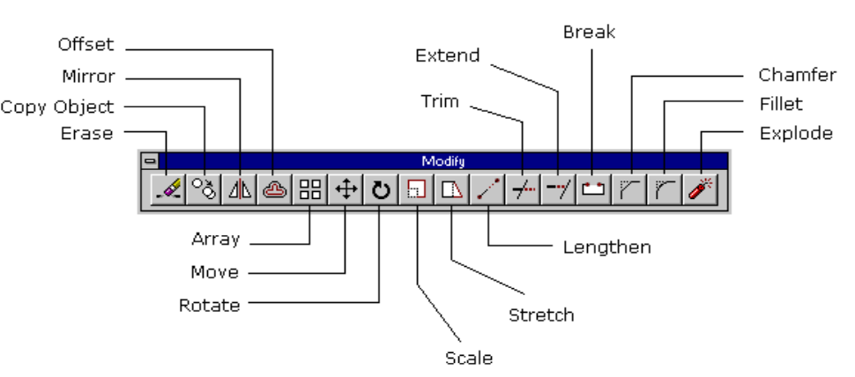

* **Different command in modify toolbar:**

Modify toolbar consist of the following commands;

1. **Erase(e):** 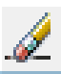

* It is used to erase a drawing.
* It can be activated by clicking its icon in modify tool bar.
* After activating the command object is selected and space is pressed.

1. **Copy(co):** 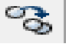

* It is used to make copies of drawing.
* After activating the command object is selected and base point is selected to copy object.
* Displacement can also be entered.

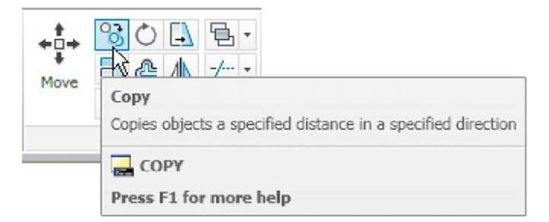

1. **Mirror (mi)** : 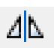

* It is used to generate mirrored drawing of drawn object.
* It can be activated by clicking its icon in modify tool bar.
* After activating the command object is selected and space is pressed.
* Then first and last point of mirror line is selected and a mirrored drawing is obtained.

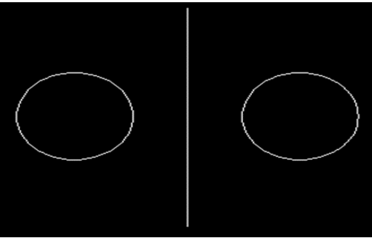

1. **Offset (o):** 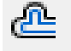

* Most models include a lot of parallel lines and curves.
* Creating them is easy and efficient with the OFFSET command.
* It can be activated by clicking its icon in modify toolbar.
* After activating the command original object drawing is selected and the offset distance is specified, and click to indicate on which side of the original drawing the result is required.

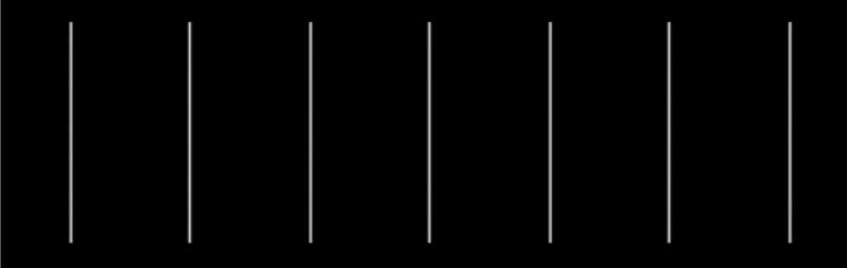

1. **Move: (m**) 

* Moves objects a specified distance in a specified direction.
* It can be activated by clicking its icon in modify toolbar.
* After activating the move command object is selected and base point is selected to move it or displacement can also be entered.

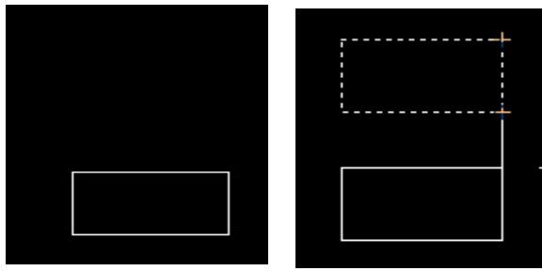

1. **Rotate (rot):** 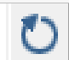

* It is used to rotate selected objects around a base point to an absolute angle.
* It can be activated by clicking its icon in modify toolbar.
* After activating the rotate command object is selected and base point is selected to rotate it and angle of rotation is specified.

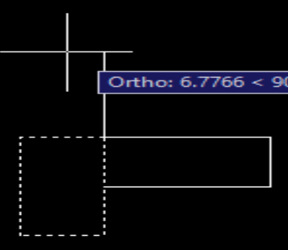

1. **Chamfer: (cha):** 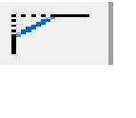

A bevel or chamfer is;

* An angled line that meets the endpoints of two straight 2D objects.
* A sloped transition between two surfaces or adjacent faces on a 3D solid.
* It can be activated by clicking its icon in modify toolbar.
* After activating command different options are available like undo/polyline/multiple/distance etc.

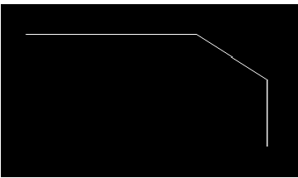

1. **Fillet: (f)** 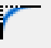

* Rounds or fillets the edges of two 2D objects or the adjacent faces of a 3D solid.
* It can be activated by clicking its icon in modify toolbar.
* After activating command different options are available like Undo/Polyline/Radius/Trim/Multiple etc.

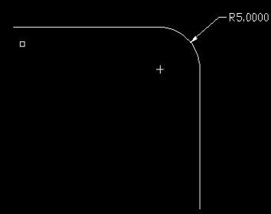

1. **Explode: (x):** 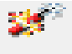

* Breaks a compound object into its component objects.
* It can be activated by clicking its icon in modify toolbar.

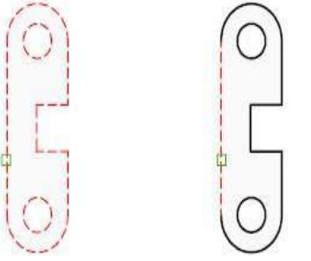

1. **Array (ar):** 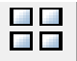

* Creates copies of objects arranged in a pattern.
* It can be activated by clicking its icon in modify toolbar.

Array is of two types:

**Rectangular Array:-**

Distributes copies of the selected object into any combination of rows, columns, and levels.

**Polar Array:-**

Evenly distributes copies of the object in a circular pattern around a center point or axis of rotation.

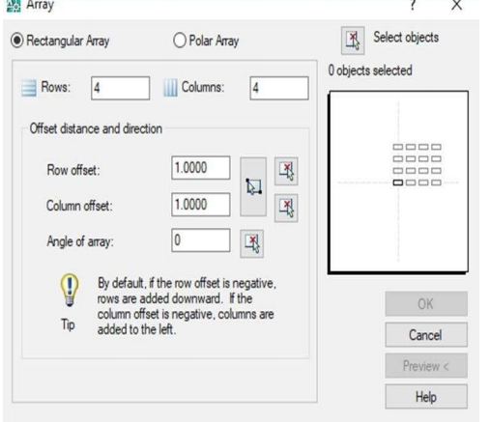

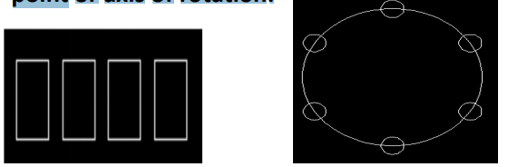

1. **Trim (tr):** 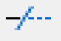

* Trims objects to meet the edges of other objects.
* It can be activated by clicking its icon in modify toolbar

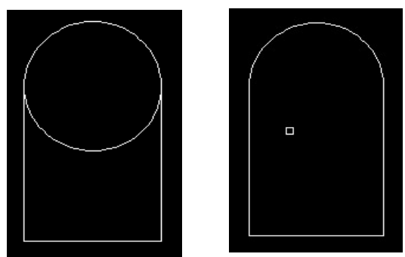

1. **Stretch**: 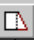

* The **Stretch command** can be used to move one or more vertices of an object whilst leaving the rest of the object unchanged.
* It can be activated by clicking its icon in modify toolbar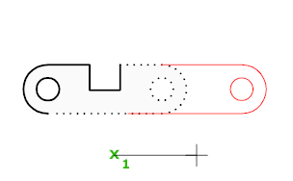

1. **Scale**: 

* The **Scale command** can be used to **change** the size of an object or group of objects.
* You are prompted for a pick point about which the selection set will be scaled.
* It can be activated by clicking its icon in modify toolbar

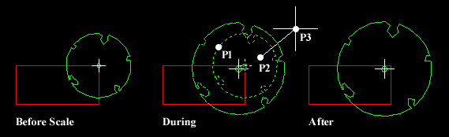

1. **Lengthen:** 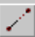

* Changes the length of objects and the included angle of arcs.
* You can specify changes as a percentage, an increment, or as a final length or angle.
* **LENGTHEN** is an alternative to using TRIM or EXTEND.
* It can be activated by clicking its icon in modify toolbar

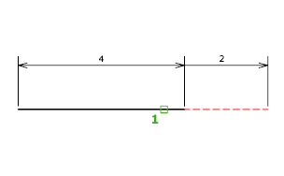

1. **Break:** 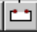

* **Breaks** the selected object between two points.
* You can create a gap between two specified points on an object, breaking it into two objects.
* If the points are off of an object, they are automatically projected on to the object.
* **BREAK** is often used to create space for a block or text.
* It can be activated by clicking its icon in modify toolbar.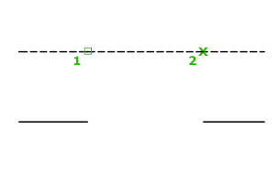

1. **Extend:**

* To extend objects, first select the boundaries.
* Then press Enter and select the objects that you want to extend.
* To use all objects as boundaries, press Enter at the first Select Objects prompt.
* It can be activated by clicking its icon in modify toolbar.

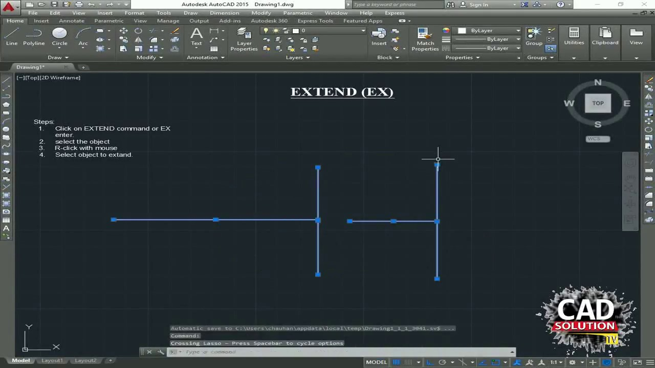

**Lab report no #10**

**Introduction to Dimension Toolbar and its different commands**

* **Introduction to dimension toolbar:**
* **DIMENSIONS Toolbar** is a toolbar for dimension Line or Draw in **AutoCAD**.
* The same commands can be used over the Text menu **DIMENSIONS**.
* Locate the tape can be anywhere on the working window in the system of  'Drag and Drop'.
* It is the drop down menu and dimension styles as well as the button to modify the **Dimensions Style.**

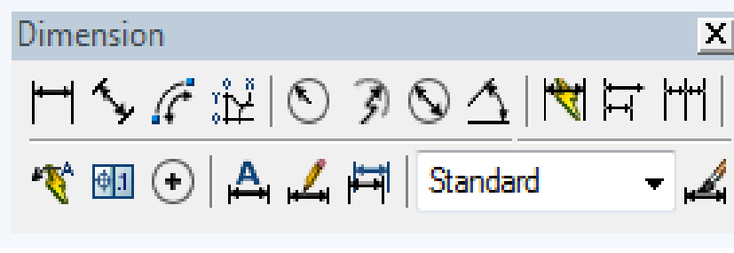

Dimension toolbar contains the following different options like linear dimension, aligned dimension etc.

1. **Linear dimension**: 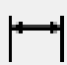

* It is used to dimension a linear line(not inclined) by specifying two ends.
* It can be activated by clicking its icon in dimension bar.

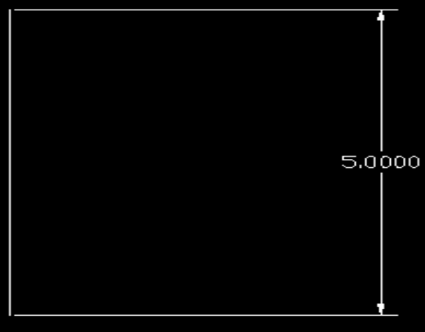

1. **Aligned Dimension:-** 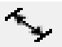

* It is used to dimension an inclined line by specifying two ends.
* It can be activated by clicking its icon in dimension bar.

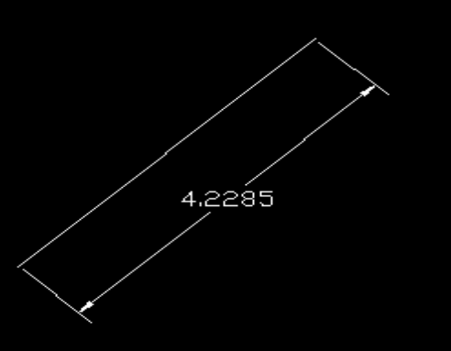

1. **Radial Dimension:** 

* It is used to specify the radius of the circle.
* It can be activated by clicking its icon in dimension bar.

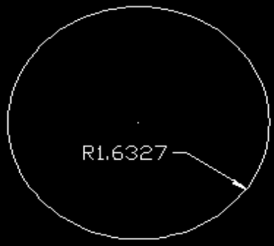

1. **Diameter Dimension**: 

* It is used to specify the diameter of the circle.
* It can be activated by clicking its icon in dimension bar.

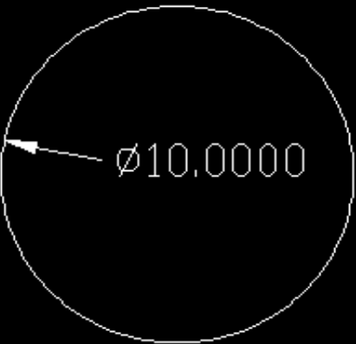

1. **Dimension Bar**: 

* It creates jogged dimensions for circles and arcs.
* It measures the radius of the selected object and displays the dimension text with a radius symbol in front of it.
* The origin point of the dimension line can be specified at any convenient location. It can be activated by clicking its icon in dimension bar

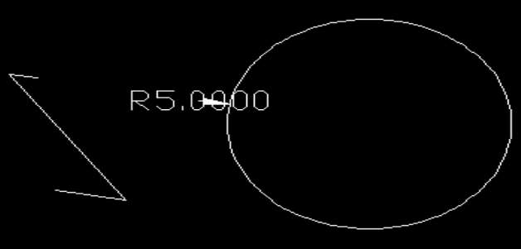

1. **Angular Dimension:** 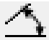

* It is used to specify angle between two objects.
* It can be activated by clicking its icon in dimension bar.

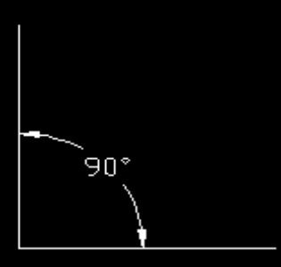

1. **Dimension Update:** 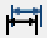

* Dimension can be updated by clicking in the draw tool bar.

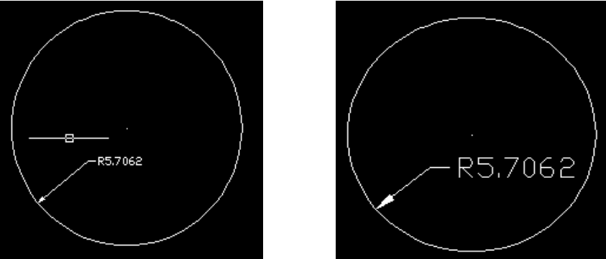

1. **Override dimension**: 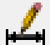

* It is equivalent to changing a dimensioning system variable without changing the current dimension style. ...
* For example, if you choose **Override** in the Dimension Style Manager, and change the color of extension lines in the **Override** Current Style dialog box, Lines tab, the current dimension style remains unchanged.

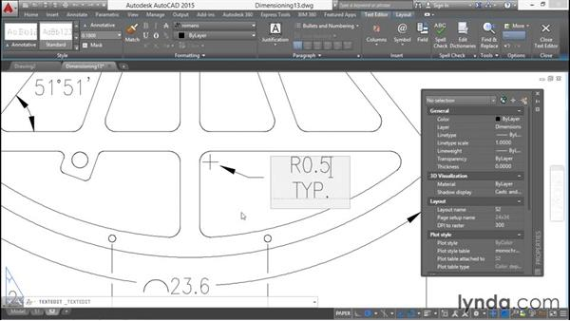

1. **Continue dimension**: 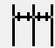

* Creates a **dimension** that starts from an extension line of the previous or selected **dimension**.
* Automatically continues creating additional **dimensions** from the last linear, angular, or ordinate **dimension** created, or from a selected extension line.
* The **dimension** lines are lined up automatically.

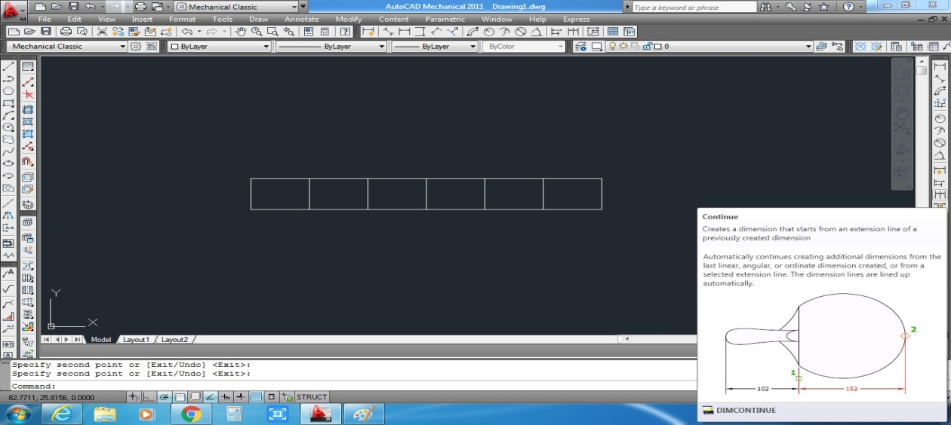

1. **Baseline dimension**: 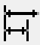

* Creates a linear, angular, or **ordinate dimension** from the **baseline** of the previous or selected **dimension**.
* The default spacing between **baseline dimensions** can be set from the **Dimension** Style Manager, Lines tab, **Baseline** Spacing (DIMDLI system variable).

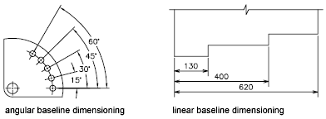

1. **Center mark dimension**: 

* To add a **center mark** to a circle or arc select this tool from Centerlines panel of Annotate tab.
* When the radius of this circle is changed using grips or using properties palette the **center mark** will adjust its **size** to the new **dimensions** of the circle.

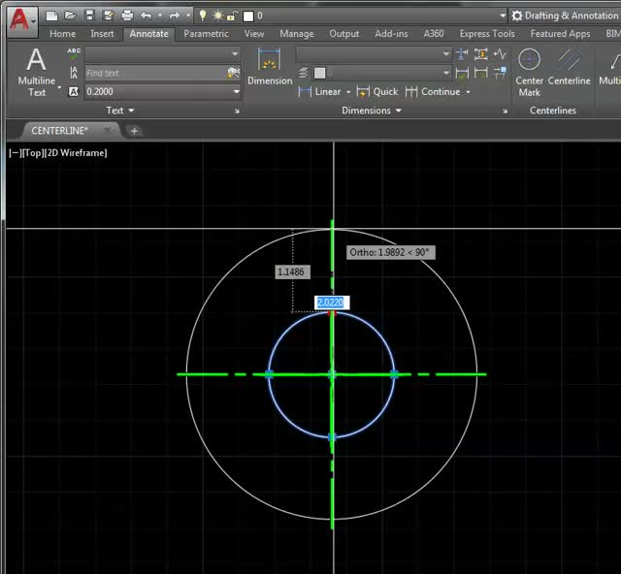

1. **Leader dimension:** 

* Creates text using the In-Place Text Editor when you specify an insertion point and a second point for the text boundary. ...
* The text is offset from the hook line by the distance specified under Offset from **Dim** Line on the Text tab of the New, Modify, or Override **Dimension** Style dialog box

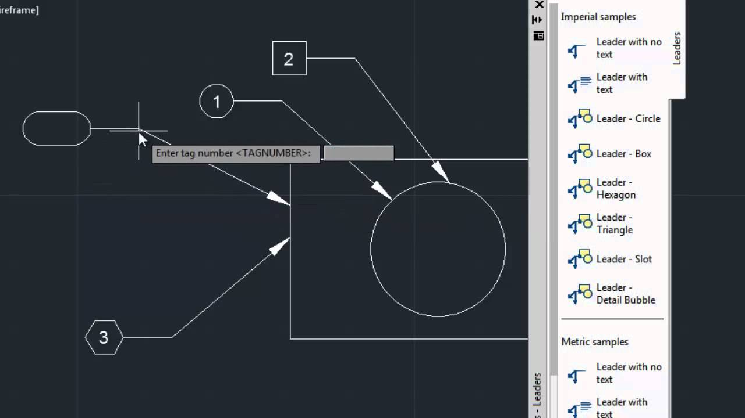

1. **Jogged dimension**: 

* **Jog** lines are used to represent a **dimension** value that does not display the actual measurement in a linear **dimension**. ...
* To reposition the **jog**, select the **dimension** and then select the grip.
* Move the grip to another point along the **dimension** line.

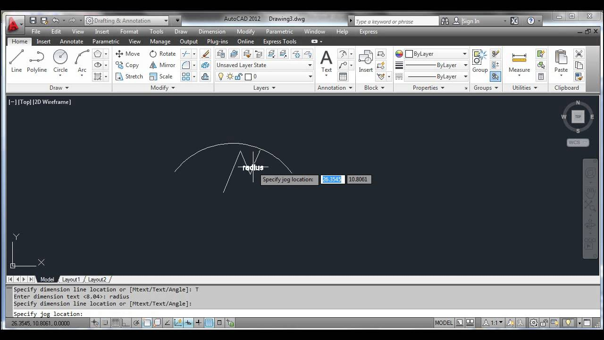

1. **Ordinate dimension:** 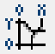

* **Ordinate dimensions** measure the perpendicular distances from an origin point called the datum, such as a hole in a part.
* The datum is established by the current location of the UCS origin. ...
* If you do not want jogs in the **ordinate** leaders, turn on Ortho mode

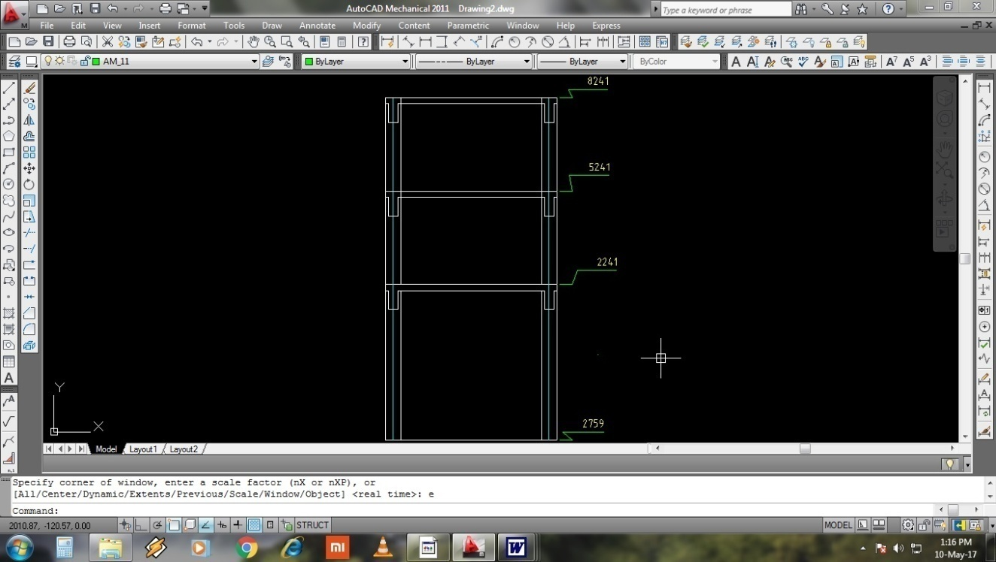

**Lab report no #11**

**Practicing 2D figure**

**Practicing 2D figure**

**Figure # 01**

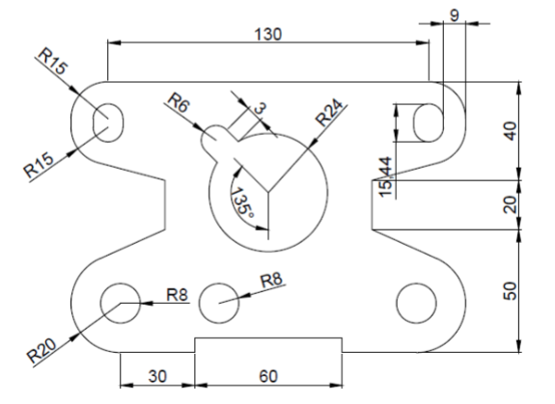

**Steps of Construction:**

1. Fix UCS icon and set drawing and dimensioning units as Engineering.
2. Turn on ORTHO mode and OSNAP.
3. Draw a line of length 130 units.
4. Then at the end of this line draw another line of length 40 unit.
5. Draw another line at the end of this 40 units line to the left side with a length of 40 units.
6. Now fillet these lines with radius of 20 units.
7. Now at the center of this arc draw a circle of radius 8 units.
8. Now at the end of 40 units horizontal line draw a vertical line of length 10 units.
9. Now off the ORTHO and meet the end of this line to the Arc.
10. Trim the unwanted areas.
11. Extend the end of this aligned line vertically with a length of 20 units.
12. Now with reference to the bottom 130 units line draw another line on the top of length 130 units.
13. Now from the right end of this 130 units line draw a line of length 30 units.
14. Join the end of this 30 units line with the end of 20 units line.
15. Now fillet the 130 units line and end of 30 units line with radius of 15.
16. Now at the displacement of 9 units draw a rectangle of sides 15.44 and 10 units.
17. And at the end erase the 10 units lines and fillet the both ends.
18. Now mirror this whole to the other side.
19. Now draw a circle of radius of 24 units, at a distance of 40 units from the mid-point of top 130-unit line.
20. And at the last draw two lines from the circle with a length of 5 units and 6 units apart from each other and draw a tan, tan, radius circle of radius 3 units.
21. Trim the unwanted parts from the drawing.

**Figure # 02**

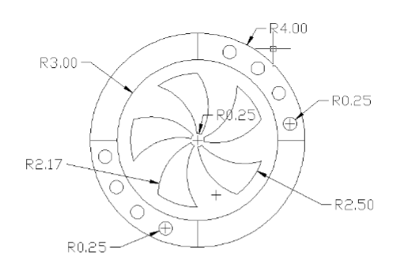

**Construction Steps:**

1. Fix UCS icon and set drawing and dimensioning units as Engineering.
2. Turn on ORTHO mode and OSNAP.
3. Draw a circle of diameter 6’’.
4. Draw a circle of diameter 8’. 5. Draw a circle of radius 3.5’.
5. Draw a circle of radius2.17’ and 2.50’.
6. Using construction line, draw angles of 18, 36, 54 and 72 degree that pass-through center of circles.
7. Now draw circles having radius 0.25’’ keeping centers the intersection points of construction lines at circle of radius3.5’.
8. Use polar array to draw these circles on other side.
9. Use three-point arc to draw fans.
10. Use trim command to trim unwanted drawing.
11. Dimension the drawing using dimension toolbar

**Lab report no #12**

**Engineering Drawing Template creation and title block drafting in AutoCAD**

* **Learning objects of this lab reports:**

After studding this lab report we will be able;

* To know about the drawing sheet and its 2D and 3D dimension.
* To know about orientation of drawing sheet.
* To know & to learn Title block creation in AutoCAD
* To learn how to create title block & its template.
* To learn the stepwise procedure of creating tamplete and title block in AutoCAD.
* To know more about AutoCAD.
* **Drawing sheet:**
* AutoCAD provides you with the ability to create a sheet layout from one of several existing templates.
* The sheet layout is based upon a sheet set that you can create using the "Create Sheet Set Wizard." Sheets created from your sheet set are stored in the "AutoCAD Sheet Sets" folder of your "My Documents" folder, allowing you to easily locate any sheet layouts that you generate within the AutoCAD program.
* **How to set the dimension of drawing sheet:**
* Click the layout tab for which you want to set the paper size.
* Click Output tabPlot panelPage Setup Manager.  Find
* In the Page Setup Manager, Page Setups area, select the page setup that you want to modify.
* Click Modify.
* In the Page Setup dialog box, under Paper Size, select a paper size from the list. Click OK.
* In the Page Setup Manager, click Close.

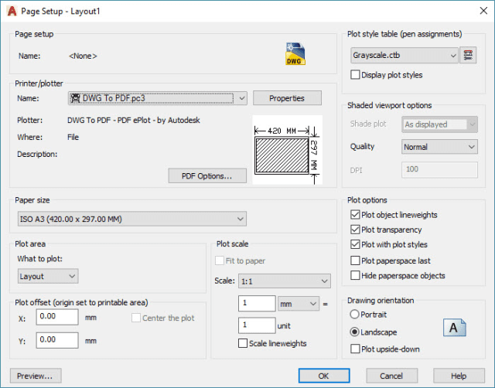

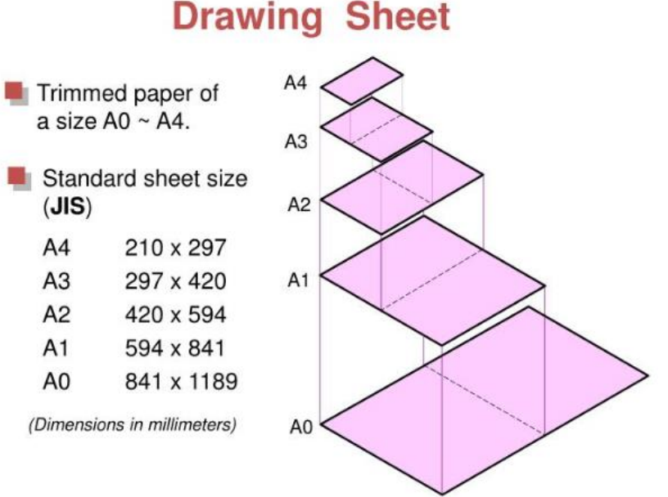

* **Orientation of drawing sheet:**
* Click the layout tab for which you want to set the drawing orientation.
* Click Output tabPlot panelPage Setup Manager.  Find
* In the Page Setup Manager, Page Setups area, select the page setup that you want to modify.
* Click Modify.
* In the Page Setup dialog box, under Drawing Orientation, do one of the following:
* If your drawing is horizontal, select Landscape.
* If your drawing is vertical, select Portrait.
* To rotate 180 degrees, select either Portrait or Landscape, and then select Plot Upside-Down.
* Click OK.
* In the Page Setup Manager, click Close.



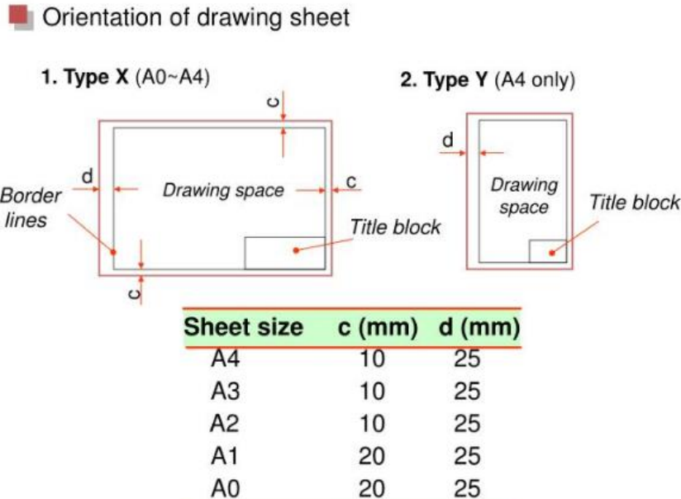

* **Title block:**
* The title block is a border drawing inserted as an AutoCAD block on another drawing. The title block utility can update attributes on the title block.
* Start a blank new drawing.
* Draw your drawing border using standard AutoCAD commands and objects.
* Enter ATTDEF at the command prompt to insert attribute definition objects.

Note: When the border drawing is inserted as a block on another drawing, attribute definition objects become attributes.

* Enter the Tag name, for example DESC1, DESC2, SHEET, SHEET_TOTAL.
* Set any other attribute definition properties and values.
* Select OK.
* Specify the insertion point.
* Repeat for each attribute definition for the title block.
* Save the border drawing as a DWG file.

This drawing is inserted as a block on another drawing. It can be also be inserted when creating a drawing template file, DWT. A drawing template file is used to provide consistency in the drawings that you create by providing standard style, settings, layers, and border.

Note: Run Title Block setup with this border drawing file active if using the WD_TB attribute method to link AutoCAD Electrical toolset values to the title block.

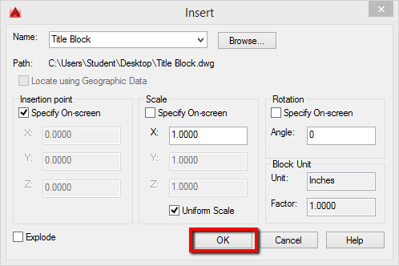

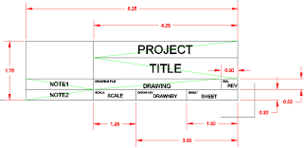

**Components of title block:**

* The title block gives the reader of the drawing critical information about the document, including the project name, author, date of issue, topic, its place within a drawing series, etc.
* It gives all of the project’s documents a consistent, professional look.

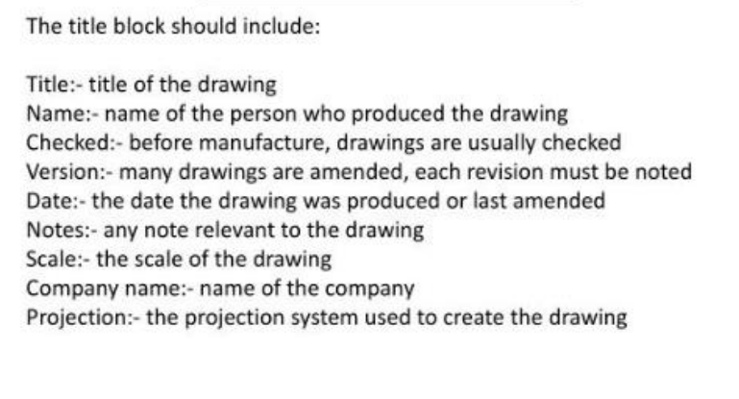

* **Field in AutoCAD:**
* Fields were first introduced in AutoCAD in 2005 mainly to populate data or pull information that can be translated onto other sheets.
* A field is a text string in AutoCAD that contains instructions to display data that you expect to change during the design process or lifecycle of a drawing and/or drawing package. A greyed out area in a drawing indicates that a field has been used and the data is linked to another source.
* A field in text contains instructions to display data that you expect to change during the life cycle of a drawing.
* Fields are special texts which update itself automatically when its linked object or property changes.
* For example, you can add a field which represents the area of an object and when the area changes field updates itself automatically.
* When a field is updated, the latest data is displayed. For example, the value of the FileName field is the name of the file. If the file name changes, the new file name is displayed when the field is updated.
* Fields can be inserted in any kind of text (except tolerances), including text in table cells, attributes, and attribute definitions. When any text command is active, Insert Field is available on the shortcut menu.

**How to insert field in AutoCAD:**

### Area Field:

* Make a circle in the drawing area and type FIELD on the command line and press enter, now select objects from Field category drop down menu and select Object from Field names panel. Now click on selection box near Object type box, and select the circle from drawing area.

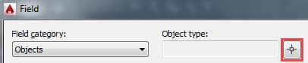

* You will notice that the Property panel will show all properties related to the circle. Select area from this list and select the format in which you want the area to represent. Click ok to close the Field window and place the area field inside the circle.

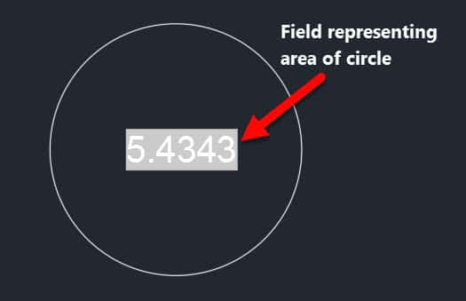

* In the example above if you change the area of the circle, the associated field will get updated to reflect the new area.

### Field Settings:

* By default, field will inherit properties of current text style and it will also show a gray background. This gray background will only remain visible in the drawing area and it will not appear when printed. Although the gray background helps in distinguishing fields from simple Mtext you can remove this background as well.
* Type OP on the command line and press enter, this will open options window. Select User Preferences tab and uncheck the radio button in the fields panel as shown in the image below. Click ok to save the changes and exit the window.

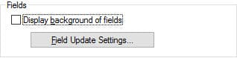

* You can also toggle the visibility of background from fields using FIELDDISPLAY system variable, where 1 makes the background visible and 0 makes it invisible.
* When the object associated with the field is changed the field updates itself automatically but in order to display that updated information you need to regenerate the drawing using RE command.
* You can also use UPDATEFIELD to manually select the fields and update them, the UPDATEFIELD command does not update the data field and you need to update it manually.
* **Stepwise procedure for creating template and title block :**
* First draw a rectangle as per drawing limit. i.e. (297mm x 210mm)
* Draw a second rectangle using offset value of 10 mm.
* 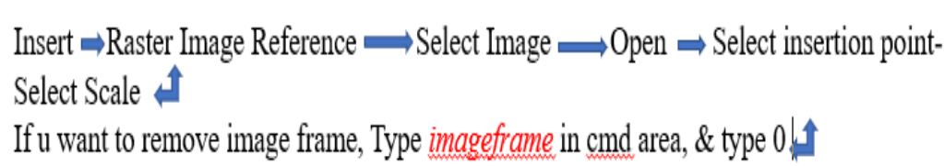Then draw a title block using Offset at the bottom with proper division for each Particular. i.e University logo, Name, Reg #, Checked by, Client, Dated etc. using Multiline text command for Particular write-up & Keep the font style and font size as per your convenience. i.e Arial/Time New Roman & 4.0. Enter logo of University using

* Then enter Field for Author, dated etc. so that it can be updated dynamically in the template. Type ‘Field’ and press Enter. Goto Field category – others- system variables- date
* How to enter Author name. Goto fileDrawing properties-Summary-Author

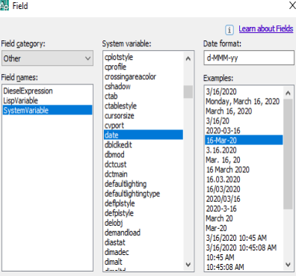

* Now save this title block as Template. But usually we used title block in layout space. We can use it in the model space as well but generally we plot our drawings in the layout. & to do this type ‘copybase’ & press enter. Select base point & then select whole template. All the template is copied in the clip board.
* Go -to Layout and delete/erase all the existing viewports. Now set size of paper by right click on layout and select page setup manager. Select modify and change page setup.

Printer/Plotter: DWG to PDF

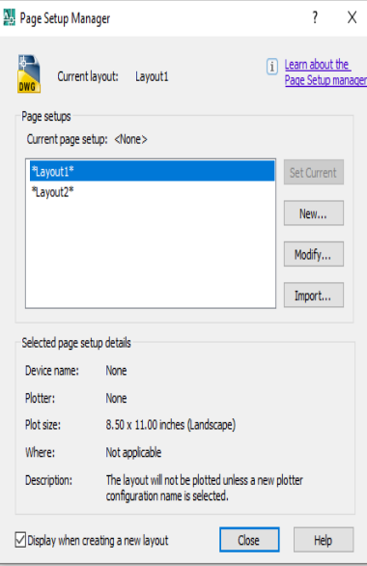 Paper size: ISO A4 297 x 210 mm

Drawing orientation: Landscape

Plot Scale 1:1

Plot area: Layout

* Now type ‘pasteclip’ in cmd area of layout 1. press enter
* Select base point at the lower left corner inside dashed lines. The template may not set in the layout limits.
* Using stretch command and bring it inside the dashed limits.
* After setting, Rename Layout 1 by ISO A4 297x210.
* Goto save as and save it as Drawing Template on desktop or any other folder.

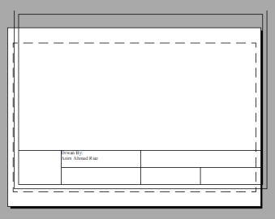

* Now open any of the 2D drawing and go to layout and invoke the saved template ‘ISO A4 297x210’
* after invoking, regenerating ‘REA’ the layout so that all the field became update. i.e Date etc.
* Then insert layout bar from ACAD. And select Display viewport dialogue and draw a viewport.

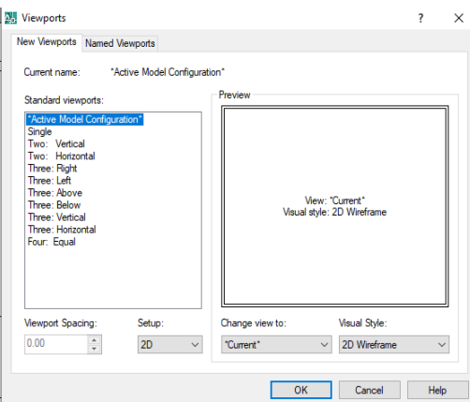

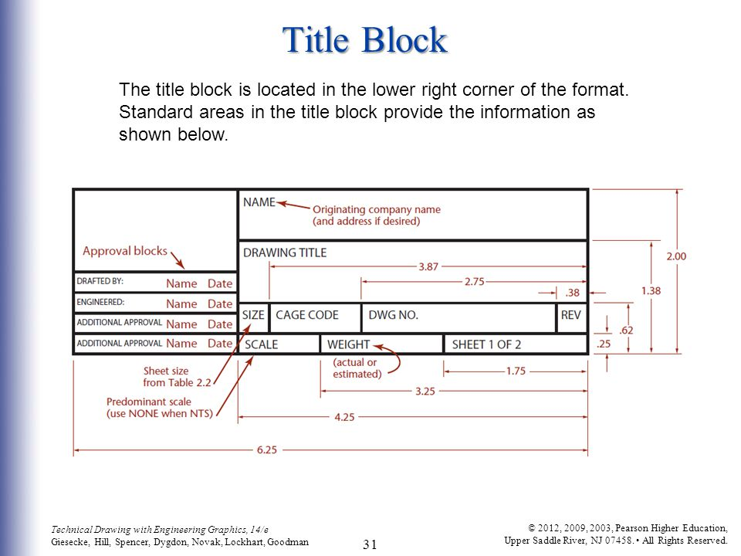

**Lab report no #13**

Introduction to Layers in AutoCAD

* **Objectives of this lab:**

After studding this lab we will be able;

* To know & to learn layers in AutoCAD.
* Layers for Continuous line, Dashed line, figure and dimensions.
* To know further about AutoCAD.
* **Layer(La):**
* Layers are a fundamental feature of AutoCAD, used to apply colors, linetypes, lineweights, transparency, as well as control plotting characteristics.
* Not using layers efficiently or placing everything on layer 0 will only cause rework and headaches for the next person working on your drawing.
* One drawing can have many layers.
* And depends on the complexity of the drawing, you may have a few to dozens of layers.
* You can use each layer to draw a specific object type. For example, you can use Wall layer to draw walls on it. Furniture layer to draw furniture on it, and so on. AutoCAD supports tens of thousands layers in a single drawing, which is virtually unlimited.
* Layers can reduce the visual complexity of a drawing and improve display performance by hiding information that you don’t need to see at the moment.
* In a house plan, you might create layers for the foundation, floor plan, doors, fixtures, electrical, and so on.
* In this example, the display is limited to the objects on the Floor Plan layer by turning off the other layers.

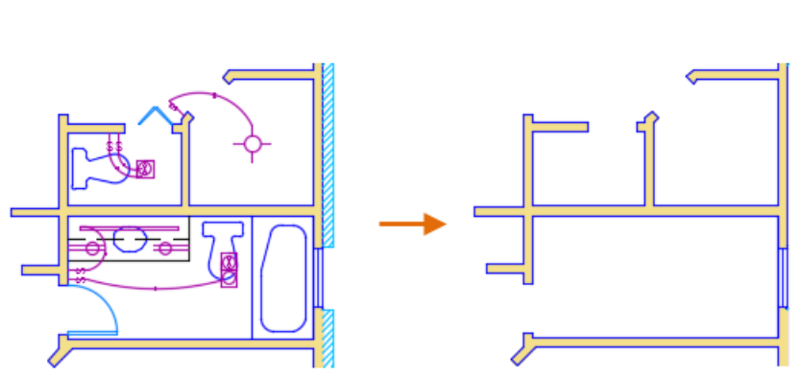

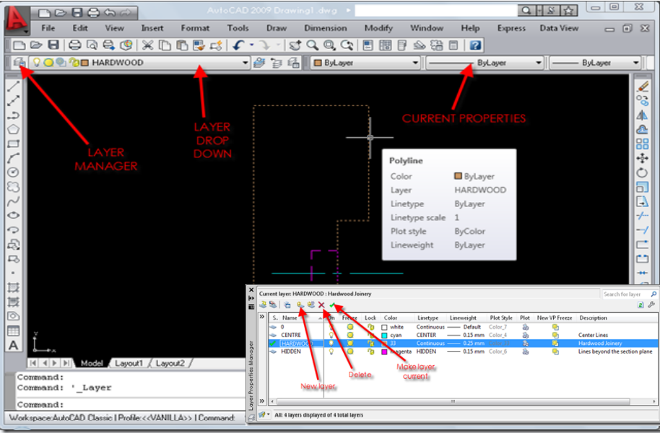

* **Why we use layer:**

Layers can be useful in many ways.

* First, because you draw objects on separate layers, it is easier for you to understand the drawing. You can quickly know an object type by checking the layer. AutoCAD drawings are just lines and arcs. Using layers can make the drawing easier to understand.

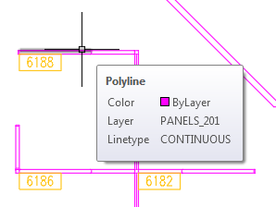

* Second, you don’t have to set properties for each object. You only need to set the properties for the layers. When you draw an object on a particular layer, it will have the same lineweight, color, linetype, and the other properties. It gives you a better control to plot your drawing.
* Third, you can hide/show or lock/unlock a layer. It means you can have greater control of your drawing. You can lock several layers to prevent they are accidentally modified. You can hide objects when the drawing becomes too complicated.
* Fourth, using layers adds a better control to select and modify objects. Let’s say you want to select all partition walls in your drawing and copy them to the next typical floor. AutoCAD doesn’t understand which lines are partition walls. However, we can tell AutoCAD to select lines on the Partition Wall layer.
* **Layer property manager:**
* we can add, delete, and rename layers, change their properties, set property overrides in layout viewports, and add layer descriptions.
* LAYER (Command)  Find

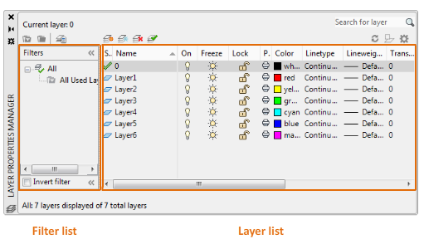

* **New Layer**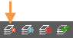

Creates a layer with a default name that you can immediately change. The new layer inherits the properties of the currently selected layer in the layer list.

* **New Layer Frozen VP In All Viewports**

Creates a layer and freezes it in all existing layout viewports. This button is accessible from the Model tab or layout tabs.

* **Delete Layer**

Deletes selected layers. The following layers cannot be deleted:

* Layers 0 and Defpoints
* Layers containing objects, including objects in block definitions
* The current layer
* Layers used in an external reference
* Layers in a partially opened drawing (Not applicable to AutoCAD LT.)

Note: Be careful about deleting layers if you are working on a drawing in a shared project or one based on a set of layering standards.

* **Set Current**

Sets the selected layer as the current layer. New objects are automatically created on the current layer. (CLAYER system variable)

## Layer List

Modify the layer properties using the layer list. Click the current setting to change the layer property for the selected layer or group of layers.

Note: The layer list can be filtered and sorted to make it easier to find and select the layers that you want to change.

* **Sort**

Click a column label to sort by that column.

* **Column Order**

Drag a column to a new location in the list to change the column order.

* **Status**
*  This layer is the current layer.
*  This layer contains objects.
*  This layer does not contain any objects. This icon is controlled by the SHOWLAYERUSAGE system variable.
*  This layer contains objects, and a property override is turned on in a layout viewport.
*  This layer does not contain any objects, and a property override is turned on in a layout viewport.
*  This layer contains objects, and xref and viewport property overrides is turned on in a layout viewport.
*  This layer does not contain objects, and xref and viewport property overrides is turned on in a layout viewport.
*  This layer contains objects, and an xref property override is turned on.
*  This layer does not contain objects, and an xref property override is turned on.

## Column Label Shortcut Menu

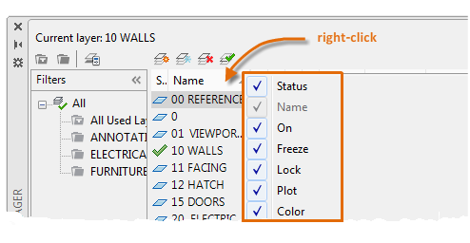

**Column Names**

Lists all columns by name. A check mark indicates that the column is included in the display. Click a column name to display or hide the column. VP Freeze, VP Color, VP Linetype, VP Lineweight, and VP Plot Style are available only when a layout viewport is active.

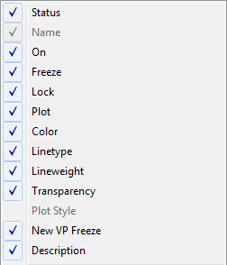

**Customize**

Displays the Customize Layer Columns dialog box, where you can specify which columns are hidden or displayed, or change the column order.

**Maximize All Columns**

Changes the width of all columns to fit the column headers and the data content.

**Maximize Column**

Changes the width of the selected column to fit the column header and the data content of that column.

**Optimize all columns**

Changes the width of all columns to fit the content in each column.

**Optimize column**

Changes the width of the selected column to fit the content in that column.

**Freeze column (or Unfreeze column)**

Freeze keeps the column, and any columns to the left, visible while scrolling. Unfreeze so that all columns scroll.

**Restore All Columns to Defaults**

Sets all columns to their default display and width settings.

## Layer List Shortcut Menu

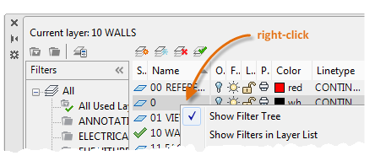

* **Layer setting:**

Displays the name of the layer or filter. Press F2 to enter a new name.

**On **

Turns the selected layers on and off. When a layer is on, it is visible and available for plotting. When a layer is off, it is invisible and not plotted, even if the setting in the Plot column is turned on.

**Freeze **

Freezes the selected layers. You can freeze layers to improve performance and reduce regeneration time in complex drawings. Objects on frozen layers are not displayed, plotted, or regenerated.

In drawings that support 3D modeling, frozen layers are not rendered. (Not applicable to AutoCAD LT.)

**Tip:** Freeze the layers that you want to remain invisible for long periods. If you plan to switch visibility settings frequently, use the On/Off setting to avoid regenerating the drawing.

**Lock **

Locks and unlocks the selected layers. Objects on a locked layer cannot be modified. Objects on locked layers appear faded and a small lock icon is displayed when you hover over the object.

Note: Set the fade level for locked layers to see which objects are on locked layers.  Find

**Color **

Displays the Select Color dialog box, where you can specify a color for the selected layers.

**Linetype**

Displays the Select Linetype dialog box, where you can specify a linetype for the selected layers.

**Lineweight**

Displays the Lineweight dialog box, where you can specify a lineweight for the selected layers.

**Transparency**

Displays the Transparency dialog box, where you can specify a transparency for the selected layers. Valid values are from 0 to 90. The higher the value, the more transparent the objects appear.

**Plot Style**

Displays the Select Plot Style dialog box where you can change the plot style for the selected layers. For color-dependent plot styles (the PSTYLEPOLICY system variable is set to 1), you cannot change the plot style associated with a layer.

**Plot **

Controls whether the selected layers are plotted. If you turn off plotting for a layer, the objects on that layer are still displayed. Layers that are off or frozen are not plotted, regardless of the Plot setting.

**New VP Freeze **

Freezes selected layers in new layout viewports. For example, freezing the DIMENSIONS layer in all new viewports restricts the display of dimensions in any newly created layout viewports but does not affect the DIMENSIONS layer in existing viewports. If you later create a viewport that requires dimensions, you can override the default setting by changing the current viewport setting.

**VP Freeze (available only from a layout tab) **

Freezes selected layers only in the current layout viewport. If a layer is already frozen or turned off in the drawing, you can't thaw the layer in the current layout viewport.

**VP Color (available only from a layout tab) **

Sets an override for the color associated with the selected layer for the current layout viewport.

**VP Linetype (available only from a layout tab)**

Sets an override for the linetype associated with the selected layer for the current layout viewport.

**VP Lineweight (available only from a layout tab)**

Sets an override for the lineweight associated with the selected layer for the current layout viewport.

**VP Transparency (available only from a layout tab)**

Sets an override for transparency associated with the selected layer for the current layout viewport.

**VP Plot Style (available only from a layout tab)**

Sets an override for the plot style associated with the selected layer for the current layout viewport. Override settings are not visible in the viewport or plotted when the visual style in the drawing is set to Conceptual or Realistic. For color-dependent plot styles (the PSTYLEPOLICY system variable is set to 1), you cannot set a plot style override.

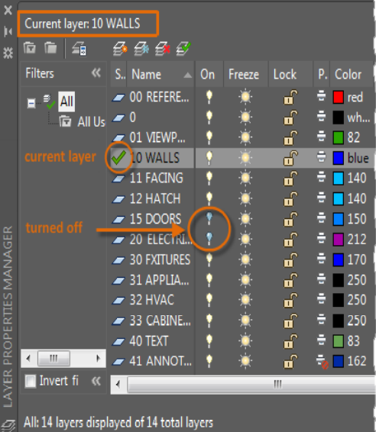

* **Image of the layer practiced by me:**

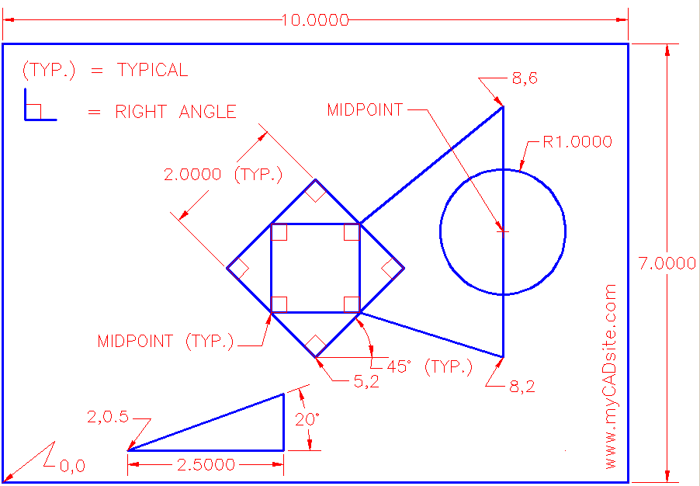

**Lab report no #14**

**Introduction to 3D modeling, Primitive solids and general solid drafting (AutoCAD V. 2020)**

# (AutoCAD v. 2020)

# Learning objectives:

* To know about 3d modeling.
* To know about and how to use AutoCAD 2020 for 3d modeling.
* To know about geometric modeling and its types i.e. Wireframe etc.
* To about views (isometric view, orthographic view, oblique view etc.)
* To know about primitive solid with figures (box, cylinder, sphere, cone and pyramid, polysolids etc.)
* To know about basic commands such as extrude command, press-pull command, sweep, loft, revolve command.

# Geometric modeling

* “Geometric modeling is as important to CAD as governing equilibrium equations to classical engi i fi ld h i d th l ineering fields as mechanics and thermal fluids.”
* intelligent decision on the types of entities necessary intelligent decision on the types of entities necessary to use in a particular model to meet certain geometric requirements such as slopes and/or curvatures.
* interpretation of unexpected results 9evaluations of CAD/CAM systems
* innovative use of the tools in particular applications innovative use of the tools in particular applications.
* creation of new attributes, or modify the obtained models to benefit new engineering applications.
* understanding of terminology

The Role of Geometric Modeling in a The Role of Geometric Modeling in a CAD System

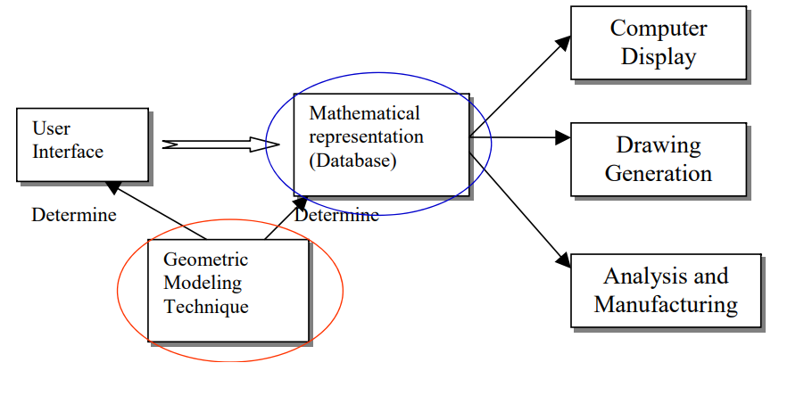

**Types of geometric modeling**

##### **Wireframe modeling**

The wireframe model is perhaps one of the earliest ways of representing a solid model. It consists of vertices and lines and is a skeletal representation of a real-world 3d object.

##### **Surface modeling**

Surface modeling represents the solid appearing object. Although it is a complicated method of representation than wireframe modeling, it is not as refined as solid modeling.

##### **Solid modeling**

Also known as volume modeling, this is the most widely used method as it provides a complete description of solid modeling. Solid modeling defines an object by its nodes, edges, and surfaces; therefore, it gives a perfect and explicit mathematical representation of a precisely enclosed and filled volume.

* **Views**

1. **Isometric view**

Isometric drawings are not actual 3d drawings, they are made with 2d geometries but they appear like 3d.

1. **Orthographic view**

Orthographic drawings display two-dimensional views of piping, valves, equipment, and structural steel in plant 3d models. The drawings can have annotations, dimensions, matchlines (plan view only), pipe gaps, and can show or hide lines and objects

1. **Oblique view**

Oblique projection is a simple type of technical drawing of [graphical projection](https://en.wikipedia.org/wiki/Graphical_projection) used for producing two-dimensional [images](https://en.wikipedia.org/wiki/Image) of three-dimensional objects.

* **1st angle of projection vs 3rd angle of projection**

1. **First angle projection:**  
   In the first angle projection, the object is placed in the 1st quadrant. The object is positioned at the front of a vertical plane and top of the horizontal plane.the object is placed between the observer and projection planes. The plane of projection is taken solid in 1st angle projection.
2. **Third angle projection:**In the third angle projection, the object is placed in the third quadrant. The object is placed behind the vertical planes and bottom of the horizontal plane. The projection planes come between the object and observer. The plane of projection is taken as transparent in 3rd angle projection.

* **Discuss primitive solid with figures (box, cylinder, sphere, cone and pyramid, polysolids etc.)**

1. **Box**

A cube is a three-dimensional solid object bounded by six square faces, facets or sides, with three meeting at each vertex

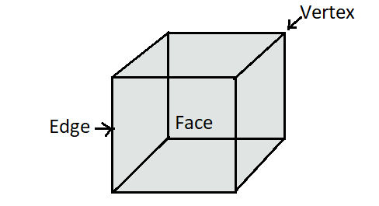

1. **Cylinder**

A cylinder stands on a circular plane surface having circular plane surfaces on its top and bottom. Thus a cylinder has two circular plane surfaces, one at its base and another at its top. It has a curved surface in the middle.it has two edges, at which the two plane surfaces meet with the curved surface. These edges are curved edges.in a cylinder there are 2 plane surfaces and 1 curved surface. There are 2 edges and no vertices.

[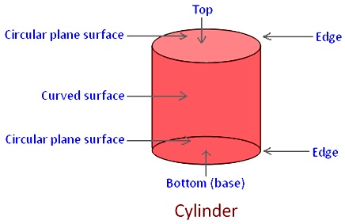](https://www.math-only-math.com/images/parts-of-a-cylinder.jpg)

1. **Sphere**

Mathematically speaking, a sphere can be defined as the set of points that are all at the same distance r from a particular point in a three-dimensional space. This distance happens to be the radius and the particular point is the centre of the sphere. The major difference between a circle and sphere is the presence of three-dimensional space.

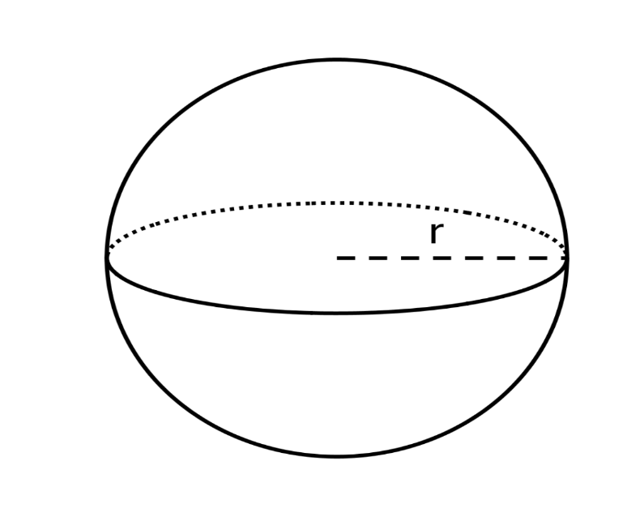

1. **Cone**

A cone has one plane circular surface, i.e. Its base and only one curved surface. In a cone there is 1 plane surface and 1 curved surface. There are 1 edge and 1 vertex.

[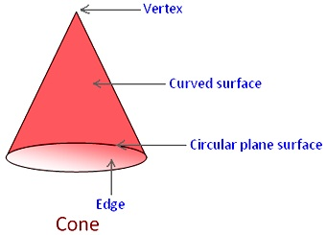](https://www.math-only-math.com/images/parts-of-a-cone.jpg)

1. **Pyramid**

A pyramid happens to be a polyhedron that comprises a base, which can be any polygon. Moreover, a pyramid consists of three or more triangular faces. These triangular faces meet at a point known as apex. These triangular sides are also known as lateral faces.

1. **Polysolids**

In [geometry](https://en.wikipedia.org/wiki/Geometry), a polyhedron (plural polyhedra or polyhedrons) is a [three-dimensional](https://en.wikipedia.org/wiki/Three-dimensional_space) shape with flat [polygonal](https://en.wikipedia.org/wiki/Polygon) [faces](https://en.wikipedia.org/wiki/Face_(geometry)), straight [edges](https://en.wikipedia.org/wiki/Edge_(geometry)) and sharp corners or [vertices](https://en.wikipedia.org/wiki/Vertex_(geometry)).

* **Extrude command**

Creates a 3d solid from an object that encloses an area, or a 3d surface from an object with open ends.

 find

Objects can be extruded orthogonally from the plane of the source object, in a specified direction, or along a selected path. You can also specify a taper angle.

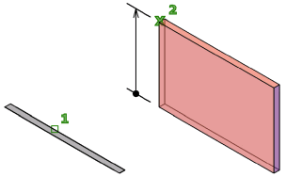

* **Press-pull command,**

Thepress or pull behavior responds to the type of object you select to create extrusions and offsets. In this example, the area between two polylines is pulled to create a 3d solid wall.

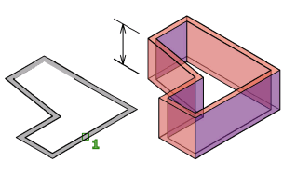

**Sweep**

Creates a 3d solid or 3d surface by sweeping a 2d object or subobject along an open or closed path.

 find

Open-ended objects create 3d surfaces, while objects that enclose an area can be set to create either 3d solids or 3d surfaces.

**Loft**

Creates a 3d solid or surface in the space between several cross sections.

 find

Creates a 3d solid or surface by specifying a series of cross sections. The cross sections define the shape of the resulting solid or surface. You must specify at least two cross sections.

* **Revolve command.**

Creates a 3d solid or surface by sweeping an object around an axis.

 find

Open profiles create surfaces and closed profiles can create either a solid or a surface. The mode option controls is a solid of surface is created. When creating a surface, surfacemodelingmode system variable controls if a procedural or nurbs surface is created.

**Lab report no #15**

**Introduction to 3D commands and 3D solid editing**

* **Objectives:**
* To know about 3D commands
* To know about solid editing
* To know about visual style
* To know about view control
* To know about 3D orbits
* **3D commands**

#### Revolve

Location: Draw > Modeling > Revolve

This AutoCAD 3D command creates a 3D solid by revolving a 2D object around an axis.

1. **Extrude**

Location: Draw > Modeling > Extrude

This AutoCAD 3D Extrude command allows the user to create a 3D object by extruding a 2D face along a line or path. For example, A cylinder can be created by selecting a 2D circle and extruding it along with a path.

#### Sweep

Location: Draw > Modeling > Sweep

This command helps the user to extrude the 2D objects without the 2D face being orthogonal to the beginning of the path.

#### Union

Location: Modify > Solids Editing > Union

This AutoCAD 3D command allows the user to combine two objects converting into one single object.

#### Subtract

Location: Modify > Solids Editing > Subtract

This command is opposite to the union command; this command works when there is a common area in both the objects. Then this command subtracts the object A from the object B.

* **3D solid editing**
* **Union**

Combines two or more 2D regions into a single, composite region.

 Find

Regions combine only with other region objects that are located on the same plane.

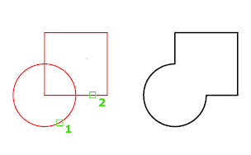

However, you can perform simultaneous UNION actions by selecting sets of regions on different planes. UNION then produces separate, combined regions on each plane.

* **Subtract**

Creates as a new object by subtracting one overlapping region or 3D solid from another.

 Find

With SUBTRACT, you can create a 3D solid by subtracting one set of existing 3D solids from another, overlapping set. You can create a 2D region object by subtracting one set of existing region objects from another, overlapping set.

Note: Using SUBTRACT with 3D surfaces is not recommended. Use the SURFTRIM command instead.

Select the objects that you want to keep, press Enter, then select the objects that you want to subtract.

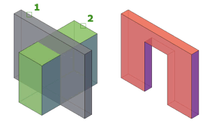

* **Intersect**

Creates a 3D solid, surface, or 2D region from overlapping solids, surfaces, or regions.

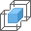 Find

With INTERSECT, you can create a 3D solid from the common volume of two or more existing 3D solids, surfaces, or regions. If you select a mesh, you can convert it to a solid or surface before completing the operation.

You can extrude 2D profiles and then intersect them to create a complex model efficiently.

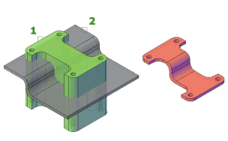

* **Shell**

The SHELL sub-command converts a 3D solid into a hollow shell with a wall of wanted thickness.

* **Slice**

Creates new 3D solids and surfaces by slicing, or dividing, existing objects.

 Find

The cutting plane is defined with 2 or 3 points by specifying a major plane of the UCS, or by selecting a planar or a surface object (but not a mesh). One or both sides of the sliced objects can be retained.

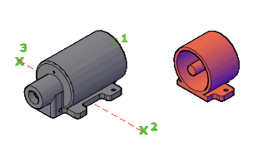

* 3D solid objects can be sliced using specified planes and surface objects
* Surface objects can be sliced by specified planes only
* Meshes cannot directly be sliced or used as slicing surfaces

Sliced objects retain the layer and color properties of the original objects, however the resulting solid or surface objects do not retain a history of the original objects.

* **Visual style**

Visual styles determines the display of edges, lighting, and shading in each viewport.

Some of them are the following.

* **2D Wireframe.** Displays objects using lines and curves. This visual style is optimized for a 2D drawing environment with high fidelity.
* **Conceptual**. Displays 3D objects using smooth shading and the Gooch face style. The Gooch face style transitions between cool and warm colors, rather than dark and light. The effect is less realistic, but it can make the details of the model easier to see.
* **Hidden**. Displays 3D objects using wireframe representation and hides lines representing back faces.
* **Realistic**. Displays 3D objects using smooth shading and materials.
* **Shaded**. Displays 3D objects using smooth shading.
* **Shaded with Edges**. Displays 3D objects using smooth shading and visible edges.
* **Shades of Gray**. Displays 3D objects using smooth shading and monochromatic shades of gray.
* **Sketchy**. Displays 2D and 3D objects with a hand-sketched effect by using the Line Extensions and Jitter edge modifiers.
* **Wireframe.** Displays 3D objects using lines and curves only. Draw order settings and fills from 2D solid objects are not displayed. The Wireframe visual style does not result in regenerating the view when you change the view direction as is the case with the 2D Wireframe visual style. The time saved will be significant in large 3D models.
* **X-ray**. Displays 3D objects with partial transparency.
* **View control**

Viewport controls are displayed at the top-left corner of each viewport, and provide a convenient way of changing views, visual styles, and other settings. You can click within each of the three bracketed areas to change the settings.

* **3D Orbit**

3DORBIT activates a 3D Orbit view in the current viewport, and the 3D Orbit cursor icon appears. You cannot edit objects while 3DORBIT is active. If you drag the cursor horizontally, the camera moves parallel to the XY plane of the world coordinate system (WCS). If you drag the cursor vertically, the camera moves along the Z axis. A small dark sphere displays temporarily, representing the target point about which your view rotates.

**Lab report no #16**

**Dimensioning of 3D Part dimensioning**

# Objectives:

* To know about dimensioning 3D figures
* To know about 3D part annotation
* To know more about autocad.
* **Procedure for 3D part annotation:**

Use commands available on the Annotate tab in a part or assembly file to add 3D annotations to your model.

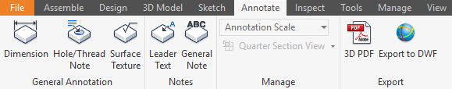

Use the Tolerance Feature command in a part file to add GD&T annotations to your model. Use the Tolerance Advisor to help you understand the state of your model and manage the Tolerance Feature annotations.

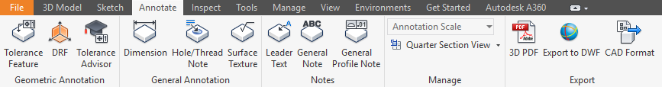

Workflows and user interface for 3D annotation commands are like annotation commands in the drawing environment. For example, after you place an annotation or click OK in a dialog box, you can continue adding symbols of the same type.

**Tip:** Set the Select Annotations filter in the Quick Access Toolbar (QAT) to manage your annotations. The Select Annotations filter also supports the window selection and All in Camera command.

## Setting 3D annotation units and standards

Changes to Document Settings Units tab do not affect 3D annotations. Click Document Settings Standard tab and then specify the Active Standard to set the units. If no active standard exists the first time you use a 3D annotation command, you are asked to choose a standard.

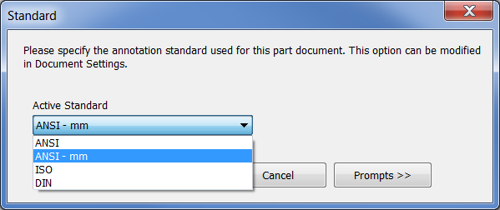

**Set the view annotation scale**

The scale of 3D annotations is independent of the Annotation Scale option in the Application Options > General tab and can be a different size in each view. Right-click a view in the browser and select Annotation Scale to set the scale.

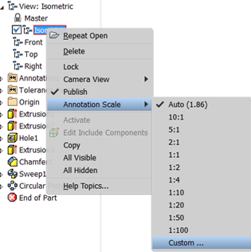

You can also control the annotation scale of the active view by selecting the Annotation Scale drop-list in the Annotate tab > Manage panel. Use the Auto setting to let the system control the size, or choose Custom to define a scale not available in the list.

**Tip:** Click Custom to open the Edit Annotation Scale dialog box and specify a custom Annotation Scale value.

After you have defined an [annotation template](https://knowledge.autodesk.com/support/autocad-map-3d/learn-explore/caas/CloudHelp/cloudhelp/2019/ENU/MAP3D-Use/files/GUID-F6A3545C-5E3C-47F9-A996-3741B310A9D0-htm.html#WS1A9193826455F5FF219F8B8B1249CF2CB82-7FEA) , use the MAPANNINSERT command to attach annotation to selected objects in your drawing.

To insert annotation

1. Click Annotate tabMap Annotation panelInsert.  Find
2. In the [Insert Annotation dialog box](https://knowledge.autodesk.com/support/autocad-map-3d/learn-explore/caas/CloudHelp/cloudhelp/2019/ENU/MAP3D-Use/files/GUID-EC03E1D3-94B2-4331-9619-34338EC87DAE-htm.html#GUID-EC03E1D3-94B2-4331-9619-34338EC87DAE), select the check box for the [annotation template](https://knowledge.autodesk.com/support/autocad-map-3d/learn-explore/caas/CloudHelp/cloudhelp/2019/ENU/MAP3D-Use/files/GUID-F6A3545C-5E3C-47F9-A996-3741B310A9D0-htm.html#WS1A9193826455F5FF219F8B8B1249CF2CB82-7FEA) to use.

To insert annotations based on multiple templates, select the check box for each template.

1. Optionally, click Advanced to change the default options and properties for the annotation.

The information from the advanced section is applied only to the highlighted template.

Note: If you subsequently [update](https://knowledge.autodesk.com/support/autocad-map-3d/learn-explore/caas/CloudHelp/cloudhelp/2019/ENU/MAP3D-Use/files/GUID-006E734B-D0CE-4FEA-80CD-05295853BB6B-htm.html) this annotation template, select the Retain option to maintain these settings.

1. Click Insert.
2. Select the objects to annotate.
3. Press Enter.

**Lab report no #17**

**Practicing 3D figure**

* **Figure #0 1**

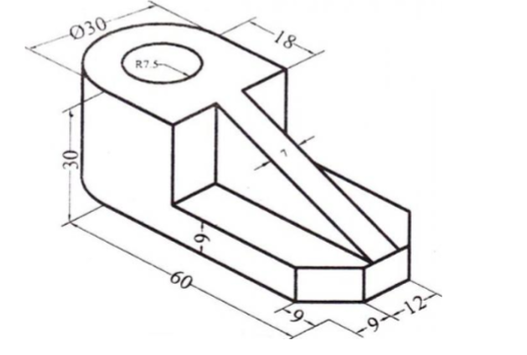

**Steps of construction:**

1. Fix the UCS icon and set units to engineering.
2. ORTHO and OSNAP on.
3. Now I set the units to mm.
4. And then drawing limit to A4 sheet by entering limits of (0,0) and (297,210).
5. Very important work to do in all drawing in zoom by entering Z and the A for all.
6. Then I set the drawing to isometric by entering <DS> in the command prompt area.
7. Now change it to iso-top in the polar snap
8. i draw a line of 30.
9. Draw another line of 60 of the ends of 30-unit line.
10. Click on champer command and champ both side with champer length of 9.
11. Now first join them all and copy this object to the upper side with displacement of 9.
12. No draw an isosceles ellipse of radius 15 unit in the object.
13. Copy this to the other object.
14. Now change to iso-left and draw a line of 18 unit on the 60-unit line and then 21 units to the upper side and then 30 units to the right and then join it to the other side.
15. Now copy the ellipse to the sides of these lines.
16. Choosing the center of ellipse draw anther one with radius of 7.5 units.
17. Now draw a line of 7 unit anywhere and copy it to the center of 30 units line and 12 units line.
18. Again, draw lines from the end of this 7 units line to the end of another 7 units line which you have copied.
19. Now in the last draw a perpendicularly from the left end of the upper 7 units line and then join it to the end left end of another 7 units line and to the 60 units line.
20. Trim unwanted lines and parts.
21. Your figure has been successfully drawn.

## Figure # 02

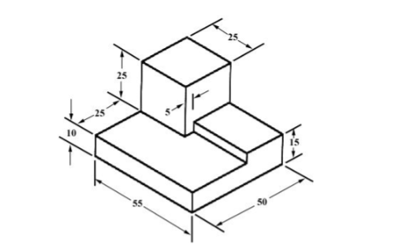

**Steps of construction:**

1. Fix the UCS icon and set units to engineering.
2. ORTHO and OSNAP on.
3. Now I set the units to mm.
4. And then drawing limit to A4 sheet by entering limits of (0,0) and (297,210).
5. Very important work to do in all drawing in zoom by entering Z and the A for all.
6. Then I set the drawing to isometric by entering <DS> in the command prompt area.
7. Now change it to iso-top in the polar snap
8. And I draw a rectangle of sides length of 50 and 55 units.
9. After this copy this rectangle to the upper side with a displacement of 10.
10. After that draw a square of sides length 25,25.
11. and extrude it to the upper side of displacement 25 at the top right corner of the rectangle.
12. Then draw a rectangle of side length 30 and 20 units at the bottom right corner.
13. Extrude this rectangle with displacement of 5.
14. Now int last enter trim command in the command prompt area and trim the unwanted lines or parts.

## Figure # 03

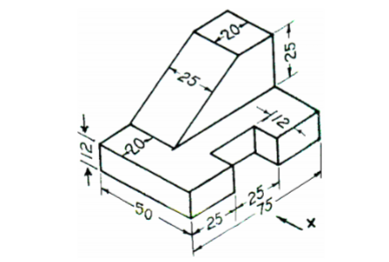

**Steps of construction:**

1. Fix the UCS icon and set units to engineering.
2. ORTHO and OSNAP on.
3. Now I set the units to mm.
4. And then drawing limit to A4 sheet by entering limits of (0,0) and (297,210).
5. Very important work to do in all drawing in zoom by entering Z and the A for all.
6. Then I set the drawing to isometric by entering <DS> in the command prompt area.
7. Now change it to iso-top in the polar snap.
8. And then I draw a rectangle of sides length 75 and 50.
9. Then I draw another rectangle with sides length of 12 and 15 units.
10. And copy it to the center of front 75 units line of the rectangle.
11. Trim the unwanted area.
12. Now join the left figure with joint command.
13. Then I copy this figure to the upper side with displacement of 12 units.
14. Now join the corner of these two objects.
15. Them I draw a rectangle of side length 25 and 20 at the upper right corner.
16. And extrude it with displacement of 25.
17. Now from the left top corner draw a line of 20 and the to the down side of 25 units.
18. Join the square sides of 25 units with this 25 units line corner by corner.
19. Now trim the unwanted lines or parts.

**­­­­­­­­­­­**

THE END